
Network Speed Dome & PTZ Camera
User’s Manual
V1.0.0

Foreword
General
This manual introduces the installation, functions and operations of the network speed dome and PTZ camera (hereinafter referred to as "the Camera"). Read carefully before using the device, and keep the manual safe for future reference.
Safety Instructions
The following signal words might appear in the manual.
Signal Words | Meaning
 | Indicates a high potential hazard which, if not avoided, will result in death or serious injury.
 | Indicates a medium or low potential hazard which, if not avoided, could result in slight or moderate injury.
 | Indicates a potential risk which, if not avoided, could result in property damage, data loss, reductions in performance, or unpredictable results.
 | Provides methods to help you solve a problem or save time.
 | Provides additional information as a supplement to the text.
Revision History
Version | Revision Content | Release Time
V1.0.0 | First release. | October 2023
Privacy Protection Notice
As the device user or data controller, you might collect the personal data of others such as their face, audio, fingerprints, and license plate number. You need to be in compliance with your local privacy protection laws and regulations to protect the legitimate rights and interests of other people by implementing measures which include but are not limited: Providing clear and visible identification to inform people of the existence of the surveillance area and provide required contact information.
Interface Declaration
This manual mainly introduces the relevant functions of the device. The interfaces used in its manufacture, the procedures for returning the device to the factory for inspection and for locating its faults are not described in this manual. Please contact technical support if you need information on these interfaces.
About the Manual
● The manual is for reference only. Slight differences might be found between the manual and the product.
● We are not liable for losses incurred due to operating the product in ways that are not in compliance with the manual.
● The manual will be updated according to the latest laws and regulations of related jurisdictions. For detailed information, see the paper user’s manual, use our CD-ROM, scan the QR code or visit our official website. The manual is for reference only. Slight differences might be found between the electronic version and the paper version.
● All designs and software are subject to change without prior written notice. Product updates might result in some differences appearing between the actual product and the manual. Please contact customer service for the latest program and supplementary documentation.
● There might be errors in the print or deviations in the description of the functions, operations and technical data. If there is any doubt or dispute, we reserve the right of final explanation.
● Upgrade the reader software or try other mainstream reader software if the manual (in PDF format) cannot be opened.
● All trademarks, registered trademarks and company names in the manual are properties of their respective owners.
● Please visit our website, contact the supplier or customer service if any problems occur while using the device.
● If there is any uncertainty or controversy, we reserve the right of final explanation.

Important Safeguards and Warnings
This section introduces content covering the proper handling of the device, hazard prevention, and prevention of property damage. Read carefully before using the device, and comply with the guidelines when using it.
Transportation Requirements
● Pack the device with packaging provided by its manufacturer or packaging of the same quality before transporting it.
● Avoid heavy stress, violent vibration, and immersion during transportation.
● Transport the device under allowed humidity and temperature conditions. Refer to the technical parameters for requirements on the transporting temperature and humidity of the device.
Storage Requirements
● Store the device under allowed humidity and temperature conditions. Refer to the technical parameters for requirements on the storing temperature and humidity of the device.
● Avoid heavy stress, violent vibration, and immersion during storage.
Installation Requirements
● Make sure that the power is off when you connect the cables, install or disassemble the device.
● For devices with earthing systems, make sure they are grounded to avoid being damaged by static electricity or induced voltage, and prevent electrocution from occurring.
● All installation and operations must conform to local electrical safety regulations.
● Use accessories suggested by the manufacturer, and installed by professionals.
● Do not block the ventilator of the device, and install the device in a well-ventilated place.
● Do not expose the device to heat sources or direct sunlight, such as radiator, heater, stove or other heating equipment, which is to avoid the risk of fire.
● Do not place the device in explosive, humid, dusty, extremely hot or cold sites with corrosive gas, strong electromagnetic radiation or unstable illumination.
● Avoid heavy stress, violent vibration, and immersion during installation.
Safe and stable power supply is a prerequisite for proper operation of the device.
● Make sure that the ambient voltage is stable and meet the power supply requirements of the device.
● Prevent the power cord from being trampled or pressed, especially the plug, power socket and the junction from the device.
● For devices that can be powered by multiple supplies, do not connect them to two or more kinds of power supplies; otherwise, the device might be damaged.
● Refer to the specific user’s manual for the power requirements of single device.
It is recommended to use the device with a lightning protector for better lightning-proof effect.
Operation Requirements
A suitable operating environment is the foundation for the device to work properly. Confirm whether the following conditions have been met before use.
● Use the device under allowed humidity and temperature conditions. Refer to the technical parameters for requirements on the operating temperature and humidity of the device.
● Use the device on a stable base.
● Do not let any liquid flow into the device to avoid damage to internal components. When liquid flows into the device, immediately disconnect the power supply, unplug all cables connected to it, and contact after-sales service.
● Do not plug or unplug RS-232, RS-485 and other ports with the power on, otherwise, the ports will be easily damaged.
● Back up data in time during deployment and use, in an effort to avoid data loss caused by abnormal operation. The company is not liable for data security.
● The company is not responsible for damages to the device or other product problems caused by excessive use or other improper use.
Maintenance Requirements
● Contact professionals for regular inspection and maintenance of the device. Do not disassemble or dismantle the device without a professional present.
● Use accessories suggested by the manufacturer, and maintain the device by professionals.

Table of Contents
Foreword I
Important Safeguards and Warnings III
1 Network Configuration 1
1.1 Network Connection 1
1.2 Logging in to the Webpage 1
1.2.1 Device Initialization 1
1.2.2 First-time Login 3
1.2.3 Device Login 4
1.2.4 Resetting Password 5
2 Preview 7
2.1 Video Window Functions 7
2.2 Encoding Settings 8
2.3 PTZ Configuration 9
2.4 PTZ Status 12
3 AI Preview 13
4 Playback 14
4.1 Playback Page 14
4.2 Playing Video or Picture 15
4.3 Clipping Video 17
4.4 Downloading Video or Picture 17
4.4.1 Downloading a Single File 17
4.4.2 Downloading Files in Batches 17
5 System Management 19
5.1 System Settings 19
5.2 Maintenance Settings 20
5.3 System Service 23
5.4 User Management 24
6 Network Settings 29
6.1 TCP/IP 29
6.2 Port 31
6.3 P2P 33
6.4 DDNS 34
6.5 Email 35
6.6 Advanced 37
6.6.1 PPPoE 37
6.6.2 UPnP 38
6.6.3 SNMP 39
6.6.4 Multicast 41
6.6.5 802.1x 41
6.6.6 QoS 42
6.6.7 RTMP 43
6.6.8 FTP 44
6.6.9 NAS 45
6.6.10 HTTPS 46
6.6.11 Firewall 52
6.6.12 ONVIF 53
6.6.13 Remote Log Records 54
7 Video and Audio Settings 55
7.1 Video Settings 55
7.1.1 Video Stream 55
7.1.2 Region of Interest 57
7.2 Audio Settings 58
8 Image Settings 60
8.1 Display Settings 60
8.1.1 Image Configuration 60
8.1.2 Adjustment Configuration 62
8.2 OSD Settings 65
8.3 Privacy Mask 66
8.4 PTZ Settings 67
8.4.1 Configuring Basic Settings 67
8.4.2 Configuring PTZ Operation 68
8.4.2.1 Preset Point 68
8.4.2.2 Tour Group 69
8.4.2.3 Linear Scan 70
8.4.2.4 Pattern 71
8.4.2.5 Horizontal Rotation 71
8.4.2.6 PTZ Limit 72
8.4.3 Configuring Schedule Task 72
9 Event Management 74
9.1 Basic Event 74
9.1.1 Motion Detection 74
9.1.2 MD2.0 76
9.1.3 Audio Detection 77
9.1.4 Video Tampering 78
9.1.5 Scene Changing 78
9.1.6 Alarm Linkage 79
9.2 VCA Option 80
9.3 VCA 81
9.4 VCA Advanced 82
9.5 Exception 84
10 Storage Management 86
10.1 Configuring Schedule 86
10.1.1 Video Recording 86
10.1.2 Holiday Schedule 86
10.2 Configuring Storage 87
10.2.1 Storage Location 87
10.2.2 Local Storage 88
10.3 Configuring Recording Control 88
10.4 Snapshot 89
10.4.1 Configuring Snapshot Parameters 89
10.4.2 Configuring Snapshot Schedule 90
10.4.3 Capture by Location 90
Appendix 1 Cybersecurity Recommendations 92

1 Network Configuration

1.1 Network Connection
To view the webpage on your computer, connect the Camera to the computer first. There are mainly two connection modes between the Camera and computer.
The models presented in the figures are for reference only, and might differ depending on different products.
Figure 1-1 Direct connection by using a network cable
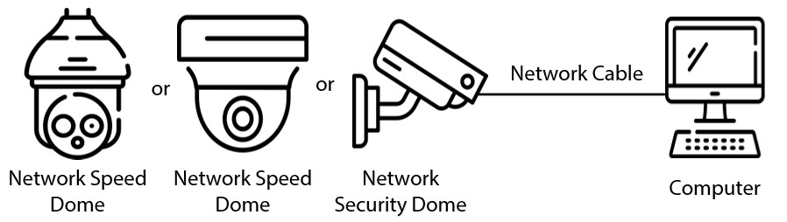
Figure 1-2 Connection by using a switch or router
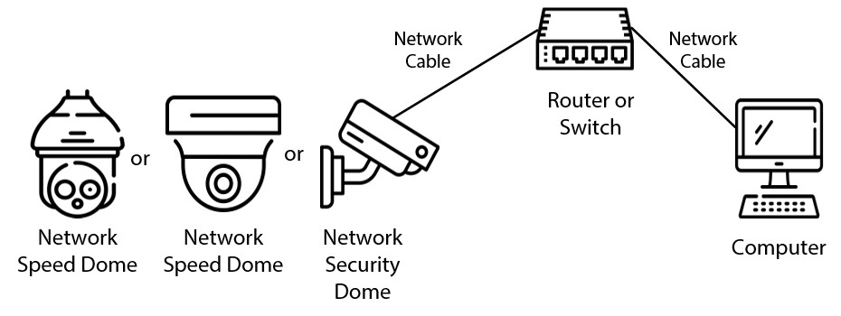
All devices have the same IP address (192.168.1.101 by default) when they are delivered out of factory. To make the Camera get access to network smoothly, plan available IP segment reasonably according to practical network environment.

1.2 Logging in to the Webpage

1.2.1 Device Initialization
Background Information
For first-time use or after you have restored the Camera to defaults, you need to initialize the Camera.
Procedure
Step 1 Open the browser, enter the IP address of the Camera in the address bar, and then press the Enter key.
Step 2 Set the password for admin account, and then click OK.
Figure 1-3 Device initialization
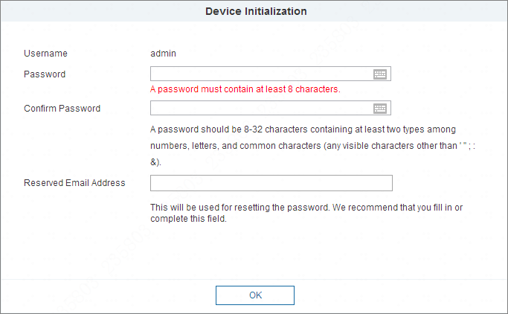
Table 1-1 Device initialization parameter description
Parameter | Description
Username | It is admin by default.
Password | Set a high security password according to the prompt of password strength. Make sure that the new password is the same as the confirming password.
Confirm Password | Enter the confirming password that shall be the same as the password you entered.
Reserved Email Address | Set the email address which is used to reset password.  Email address is enabled by default. You can disable the function as needed.
Step 3 Select Automatic detection checkbox.
After the function is enabled, the Camera will check for updates once a day automatically. There will be system notice if any update is available.
Step 4 Click Next, and the login page is displayed.
Figure 1-4 Login
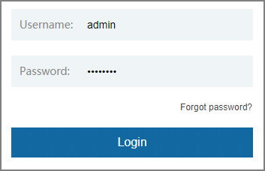

1.2.2 First-time Login
Background Information
You need to download and install the plug-in for the first-time login.
Procedure
Step 1 Open the browser, enter the IP address of the Camera in the address bar, and then press Enter.
Step 2 Enter the username and password, and then click Login.
● If you enter the wrong password for 5 times, the account will be locked for 5 minutes. After the locked time, you can log in to the web page again.
● You can set the number of allowed password attempts and locked time in Unauthorized Access.
Step 3 Download and install the plug-in according to the on-screen instruction after logging in to the webpage.
Figure 1-5 Install the plug-in
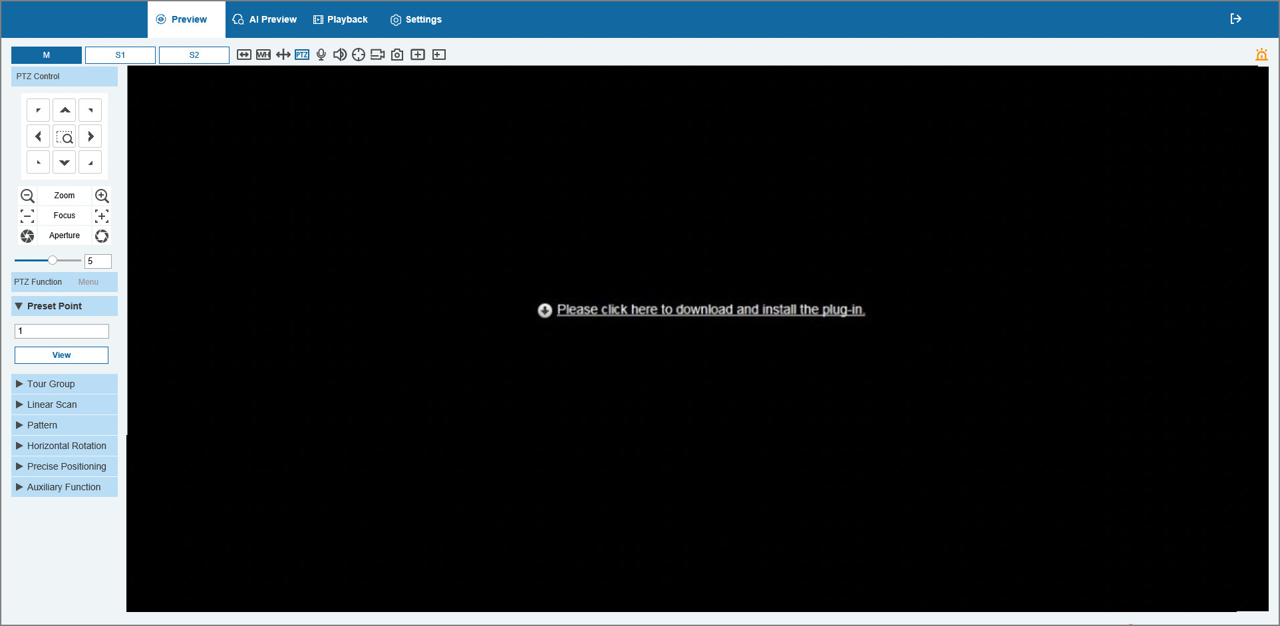
Step 4 After the plug-in is installed, the web page will be refreshed automatically, and the video is displayed on the Preview page.
Figure 1-6 Live view page
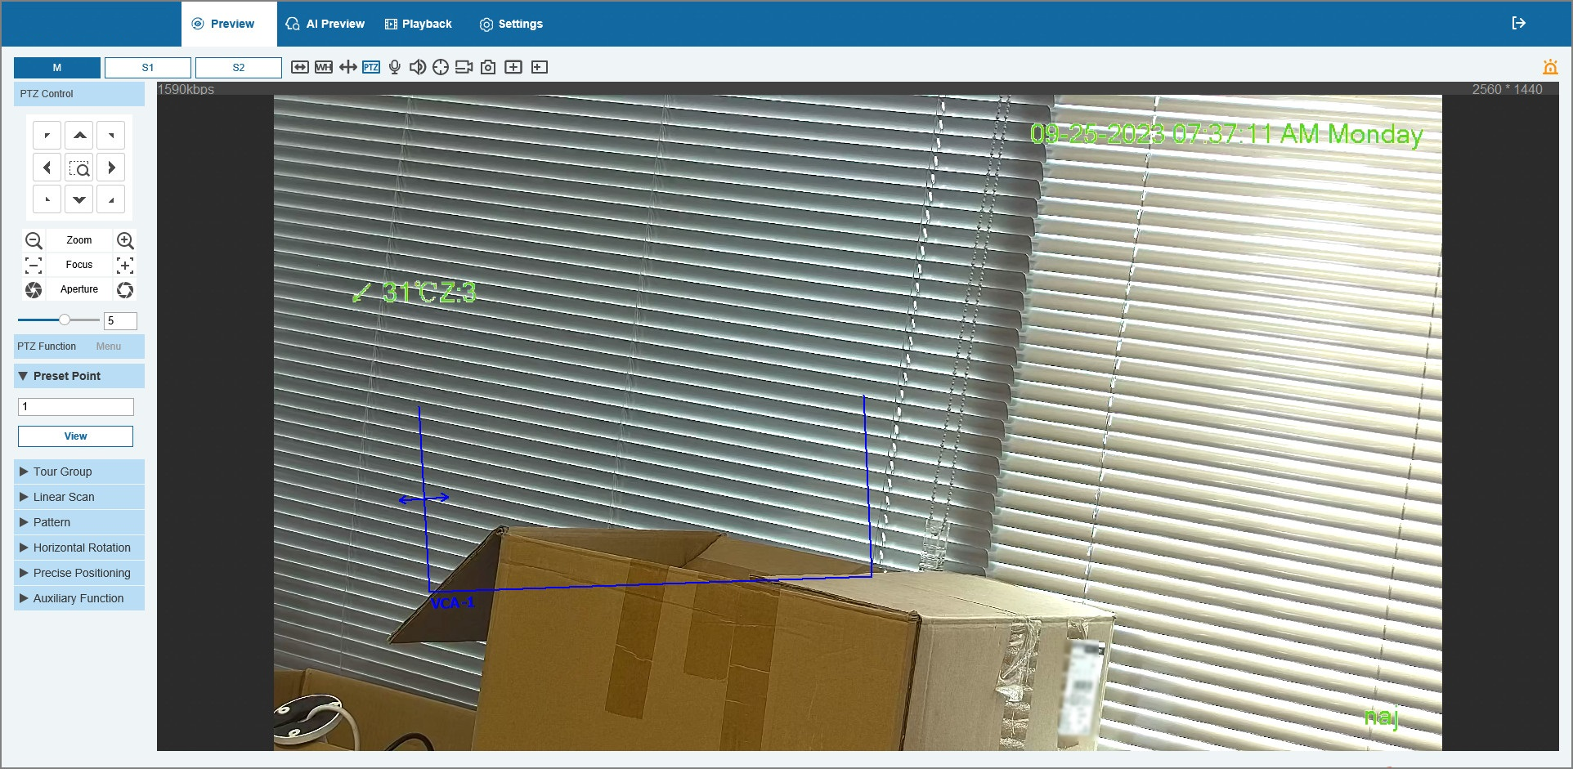
The Preview page shown in the manual is for reference only, and functions might be different depending on the model.

1.2.3 Device Login
Procedure
Step 1 Open the browser, enter the IP address of the Camera in the address bar, and then press Enter.
Figure 1-7 Device login
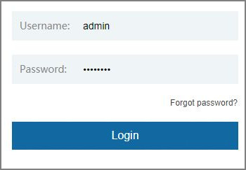
Step 2 Enter the username and password, and then click Login.
The video is displayed on the Preview page.
● If you enter the wrong password for 5 times, the account will be locked for 5 minutes. After the locked time, you can log in to the web page again.
● You can set the number of allowed password attempts and locked time. For details, see Unauthorized Access.

1.2.4 Resetting Password
Background Information
If you forget the password of the admin user, you can set the password through the provided email address.
Before resetting the password, you need to provide the email address in advance. For details, see "1.2.1 Device Initialization".
Procedure
Step 1 Open the browser, enter the IP address of the Camera in the address bar, and then press Enter.
Figure 1-8 Login
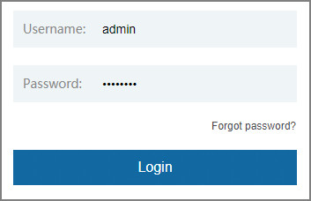
Step 2 Click Forgot password?, and then a prompt is displayed.
Figure 1-9 Prompt
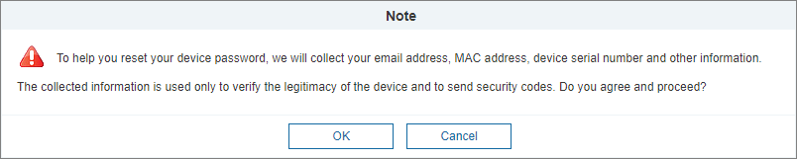
Step 3 Click OK to reset the password.
The Password Reset (1/2) page is displayed.
If you click OK, your email address, MAC address, device serial number, and other information might be collected.
Figure 1-10 Password reset (1)
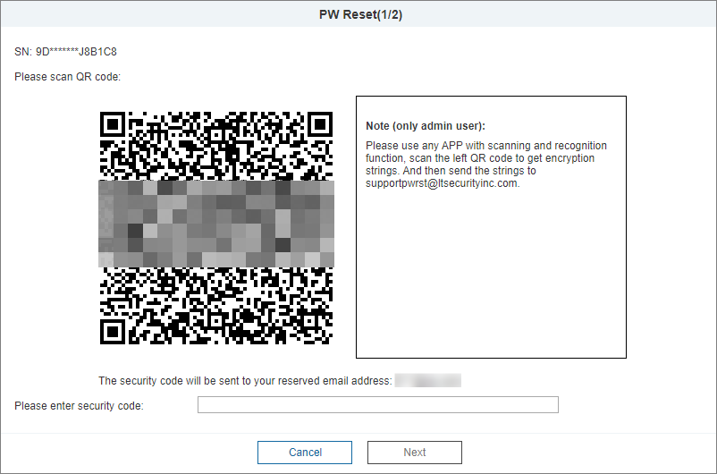
Step 4 Scan the QR code on the actual page according to the instructions, and then enter the security code received in the mailbox.
Reset the password with the security code you received within 24 hours, otherwise the code will be invalid.
Step 5 Click Next.
The Password Reset (2/2) page is displayed.
Step 6 Set the password of the admin user again.
Set a high security password according to the prompt of password strength.
Step 7 Click OK.

2 Preview
Click the Preview tab, and the Preview page is displayed.
Figure 2-1 Preview page
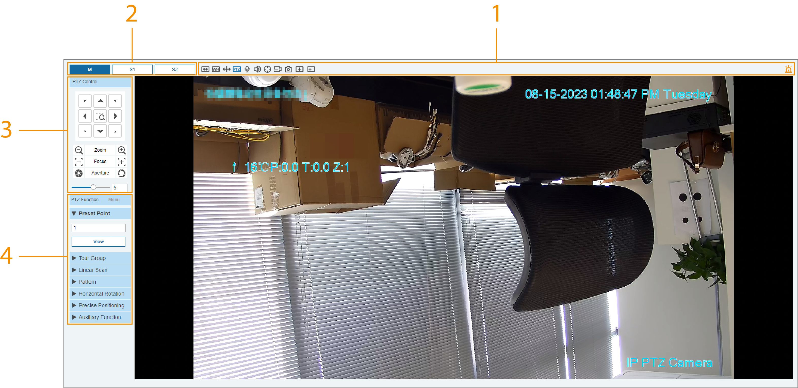
Table 2-1 Function bars description
No. | Description
1 | Video window function
2 | Encoding setting
3 | PTZ control configuration
4 | PTZ function configuration

2.1 Video Window Functions
This section introduces the functions of video window.
Figure 2-2 Video window adjustment
Table 2-2 Description of Video window adjustment parameter
Icon | Parameter | Description
 | Full Screen | Click the button to enter full screen mode; double-click or press Esc to exit.
 | Aspect Ratio | Click the button to resume original ratio or change ratio.
 | VCA | Click the button, and smart rules are displayed on the Live page after the function is enabled. The function is enabled by default.
 | PTZ | Click the button, and PTZ configurations are displayed on the Live page after the function is enabled.
 | Intercom | Click the button to enable or disable the voice interaction.
 | Sound | Click the button to enable or disable audio output of the monitoring stream.  Before using the function, you need to enable the audio of the corresponding stream in Settings > Video/Audio > Audio first.
 | Manual Tracking | Click the button, draw a box with the mouse on the live view, and then the Camera will automatically track the area in the box and zoom in.
 | Video Recording | Click the button to record video, and it will be saved to the configured storage path.
 | Snapshot | Click the button to capture one snapshot of the current image, and it will be saved to the live snapshot storage path.
 | Local zoom | You can zoom in or out the video image through two methods.  ● Click the icon, and then select an area in the video image to zoom in; right-click on the image to resume the original size. In zoom in state, drag the image to check other area.  ● Click the icon, and then scroll the mouse wheel in the video image to zoom in or out.
 | Regional Focus | Click the button, draw a box with the mouse on the live view, and then the Camera will automatically focus on the area in the box.
 | Alarm Output | Click the button to enable or disable the alarm output linkage.

2.2 Encoding Settings
Select the stream as needed.
Some devices do not support two sub streams.
Figure 2-3 Encoding setting

Table 2-3 Description of encoding setting parameter
Parameter | Description
Main Stream | It has large bit stream value and image with high resolution, but requires large bandwidth. This option can be used for storage and monitoring.
Sub Stream 1 | It has small bit stream value and smooth image, and requires little bandwidth. This option is normally used to replace main stream when bandwidth is not enough.
Sub Stream 2

2.3 PTZ Configuration
You can control PTZ by using the PTZ Control panel. You can also set preset, scanning, and other functions in the PTZ Function area.
PTZ Control
Figure 2-4 PTZ control
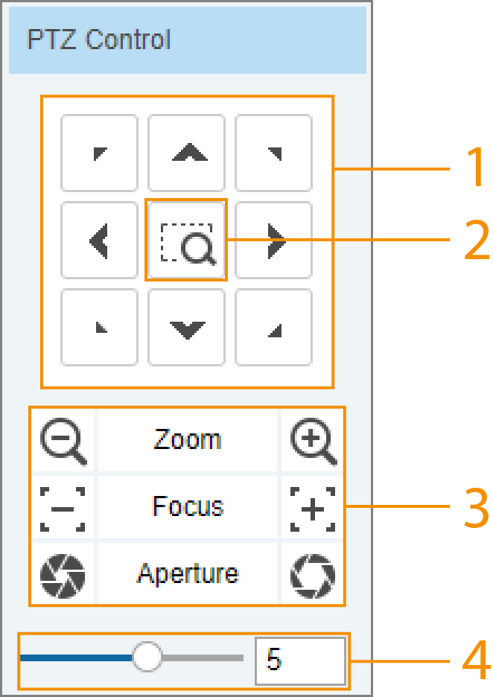
Table 2-4 Description of PTZ control parameter
No. | Parameter | Description
1 | Direction Buttons | There are 8 directions: up, down, left, right, upper left, upper right, lower left, and lower right.
2 | Position | Provides quick positioning function. Draw a box in the live view or click the live view with the mouse , and then the PTZ rotates to and focuses on the selected area rapidly.
3 | Zoom/Focus/Aperture | Click // to increase the value, and click // to decrease the value.
4 | Step | The changing speed of PTZ direction. The higher the value, the faster the speed.
PTZ Functions
Figure 2-5 PTZ functions
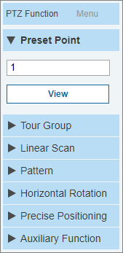
Table 2-5 Description of PTZ function
Parameter | Description
Preset point | Select Preset point from the list, enter a preset number, and then click View. The PTZ will rotate to the preset position.
Tour Group | Select Tour Group from the list, enter a tour number, and then click Start. The PTZ starts to tour.
Linear Scan | Select Linear Scan from the list, enter a scan number, and then click Start. The PTZ starts scanning, and the default number is 1.
Pattern | Select Pattern from the list, enter a pattern number, and then click Start. The PTZ starts to pattern.
Horizontal Rotation | Select Horizontal Rotation from the list, click Start, and then the Camera starts continuous 360° rotation in a horizontal way at a certain speed.
Precise Positioning | ● Select Precise Positioning from the list, enter Horizontal Angle, Vertical Angle and Zoom, and then click Positioning. The Camera will turn to the position you want.  ● One unit of the horizontal angle value or vertical angle value you enter equals 0.1 degrees.
Auxiliary Function | Select Auxiliary Function from the list, enter an auxiliary function number, and then click Aux On. The PTZ starts auxiliary number.
Menu
Figure 2-6 Menu page
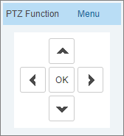
Table 2-6 Description of menu parameter
Parameter | Description
Direction Buttons | Click the up and down buttons to select parameters, and click the left and right buttons to select parameter values.
OK | Confirmation button.
Click Menu to open the OSD menu. The OSD menu is displayed on the live view.
Figure 2-7 OSD menu
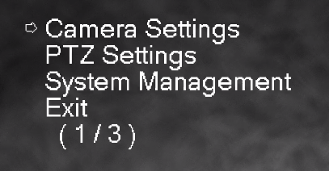
You can finish the following settings through the menu.
● Camera settings: For details, see "8.1 Display Settings".
● PTZ settings: For details, see "8.4 PTZ Settings".
● System management: For details, see "5 System Management".

2.4 PTZ Status
On the Preview page, the PTZ status is displayed at the lower-left corner.
Click this button, and PTZ configurations are displayed on the Preview page after the function is enabled.

3 AI Preview
You can select in Face Detection mode.
Prerequisites
● Only IE browser supports this page.
● Make sure you have enabled the corresponding function in settings page.
Procedure
Step 1 Log in to the webpage of the device.
Step 2 Select AI Preview page.
Step 3 In the lower-right page, click , and then select Face Detection in the VCA Option drop-down list.
Step 4 Select the displayed attributes, and then click Save.
Figure 3-1 AI preview (face detection)
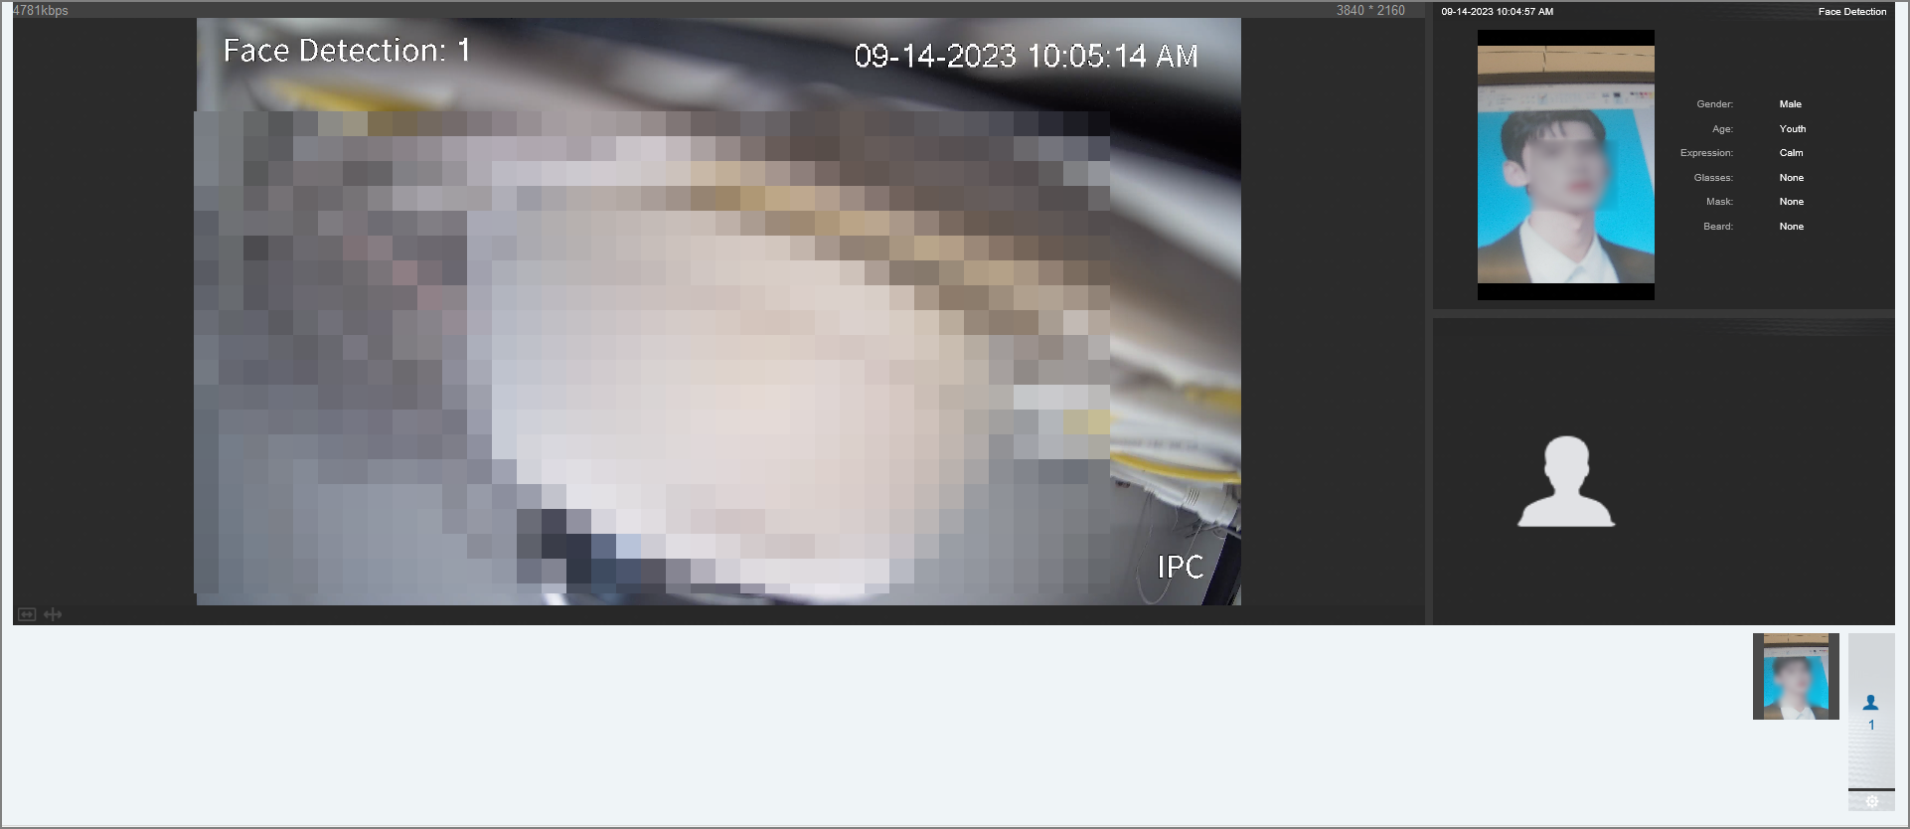

4 Playback
This section introduces playback related functions and operations, including videos and picture.
● Before playing the recording, configure record time range, record storage method, record schedule and record control. For details, see "10.1.1 Video Recording".
● Before searching for picture, configure snapshot time range, snapshot storage method, and snapshot plan. For details, see "10.4 Snapshot".

4.1 Playback Page
Click the Playback tab.
Figure 4-1 Video
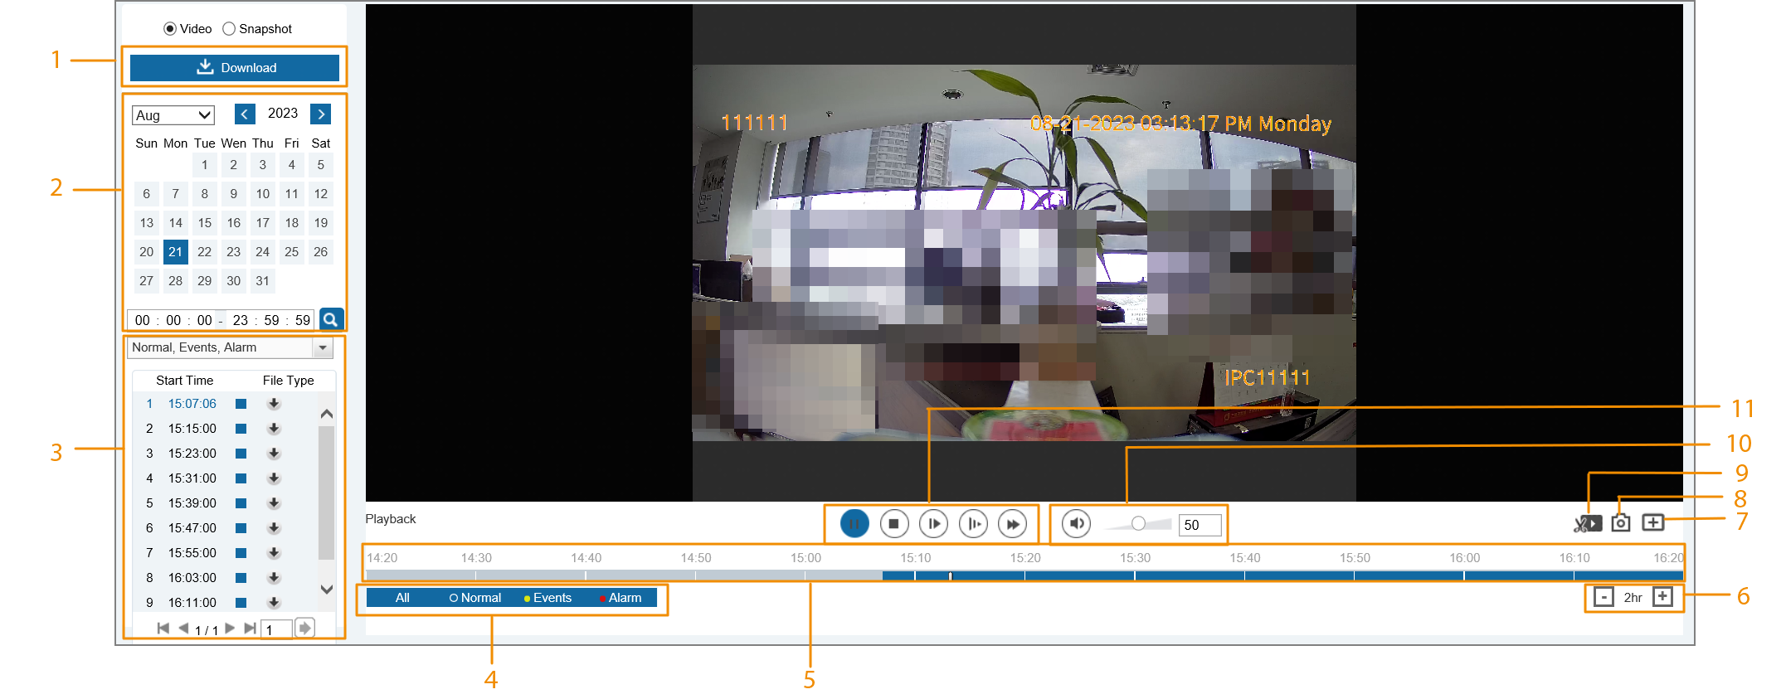
Figure 4-2 Picture
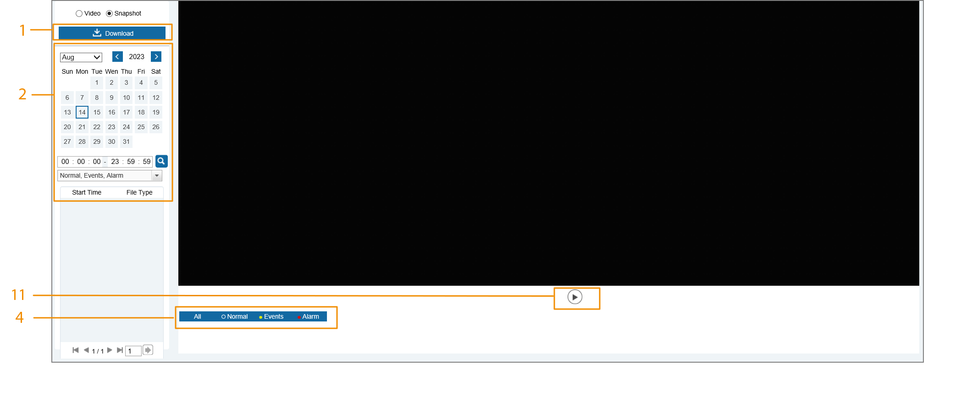
Table 4-1 Playback page description
No. | Function | Description
1 | Download | Download the video or snapshot. For details, see "4.4 Downloading Video or Picture".
2 | Playback file | You can select the record date and time.
3 | Type | You can select the corresponding recording to play and download.
4 | Record/Snapshot Type | Select the record type or snapshot type.
5 | Progress bar | Displays the record type and the corresponding period.  ● Click any point on the colored area, and the system will play back the recorded video from the selected moment.  ● Each record type has its own color, and you can see their relations in Record Type bar.
6 | Time format of progress bar | Includes 4 time formats: 30min, 1hr, 2hr and 24hr. Uses 24hr as an example, the whole progress stands for 24 hours.
7 | Local zoom | You can zoom in or out the video and picture of the selected area through two methods.  ● Click the icon, and then select an area in the video image to zoom in; right-click on the image to resume the original size. In zoom in state, drag the image to check other area.  ● Click the icon, and then scroll the mouse wheel in the video image to zoom in or out.
8 | Snapshot | Click to capture one picture of the current image, and it will be saved to the configured storage path.
9 | Video clip | Clip a certain recorded video. For details, see "4.3 Clipping Video".
10 | Sound | Controls the sound during playback.  ● : Mute mode.  ● : Vocal state. You can adjust the sound.
11 | Play control bar | Controls playback.  ● /: Play or pause recorded videos.  ● : Stop playing back recorded videos.  ● : Play the next frame.  ● : Slow down the playback.  ● : Speed up the playback.

4.2 Playing Video or Picture
This section introduces the operation of video playback and picture playback. This section uses video playback as an example.
Procedure
Step 1 Select Video or Snapshot as needed, and then configure the time.
Step 2 Select the record type from the drop-down list.
Figure 4-3 Playback list
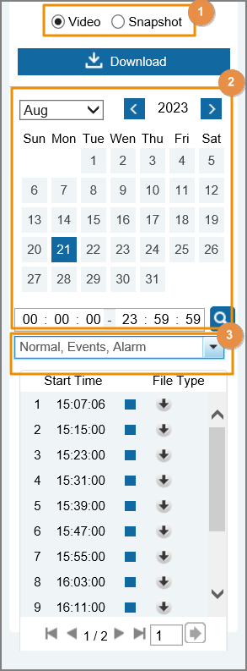
Step 3 Play the video.
● Click in the control bar.
The system plays the recorded video of the selected date (in the order of time).
● Click any point in the colored area on the progress bar.
The playback starts from that moment.
Figure 4-4 Process bar

4.3 Clipping Video
Procedure
Step 1 Select Video, and then configure the time.
Step 2 Select .
Step 3 Click on the progress bar to select the start time of the target video, and then click .
Step 4 Click again on the progress bar to select the end time of the target video, and then click .
Step 5 Click  to download the video.
The system will prompt that it cannot play and download at the same time.
Step 6 Click OK.
The playback stops and the clipped file is saved to the default storage path (C:\Users\admin\WebDownload\PlaybackRecord).

4.4 Downloading Video or Picture
Download video or picture to a defined path. You can download single video or picture file, or download them in batches. This section takes downloading video as an example.
● You can not play or download at the same time.
● Operations might vary with different browsers.

4.4.1 Downloading a Single File
Procedure
Step 1 Select Video, and then configure the time.
Step 2 Select the record type from the drop-down list.
Step 3 Click next to the file to be downloaded.
The system starts to download the file to the default path (C:\Users\admin\WebDownload\PlaybackRecord).

4.4.2 Downloading Files in Batches
Procedure
Step 1 Select Video, and then click Download.
Step 2 In the pop-up page, select the record type, set the start time and end time, and then click Search.
Figure 4-5 Download in batches
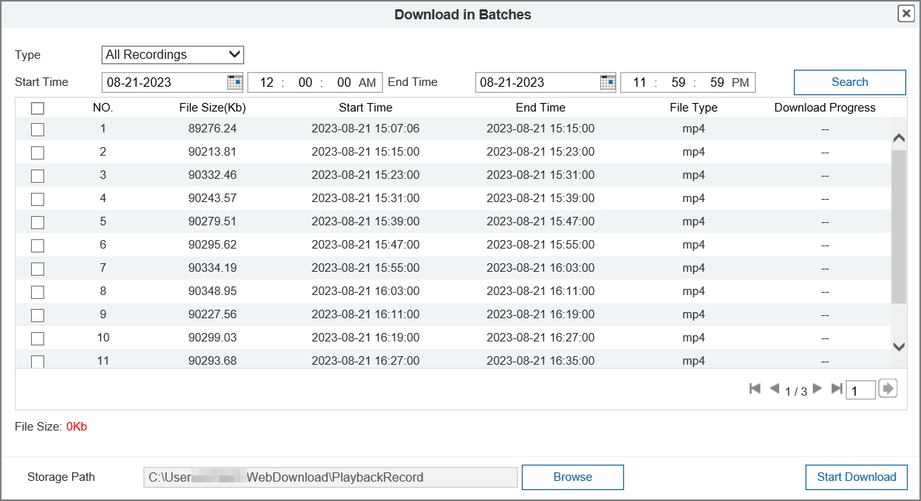
Step 3 Select the files to be downloaded, and then set the storage path.
Step 4 Click Start Download.
The system starts to download the file to the configured path.

5 System Management

5.1 System Settings
Select Settings > System > System Setting to view and configure the basic settings of the device.
Basic Information
Click Basic Info tab, and then view the basic information of the device.
You can enter the device name to change the name.
Click Default to restore the device to default settings, click OK to save the settings.
Figure 5-1 Basic information
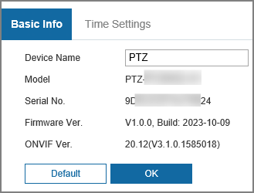
Time Settings
Click Time Settings tab, and then configure date and time parameters.
Click Default to restore the device to default settings, click OK to save the settings.
Figure 5-2 Time setting
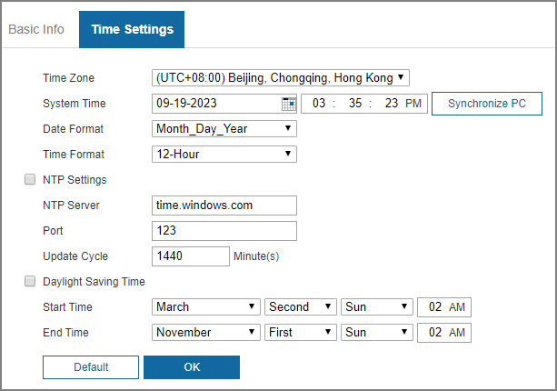
Table 5-1 Description of time parameters
Parameter | Description
Time Zone | Set the time zone to match the location of the camera.
System Time | Configure system time.  Click Synchronize PC to synchronize the system time to the computer time.
Date Format | Select the date format. Three formats are available: Year-Month-Day, Month-Day-Year and Day-Month-Year.
Time Format | Select the time format. Two formats are available: 24-Hour and 12-Hour.
NTP Settings | Select the checkbox, and then NTP (network time protocol) is enabled, the system then syncs time with the internet server in real time.  You can also enter the IP address, time zone, port, and interval of a computer which installed NTP server to use NTP.
NTP Server
Port
Update Cycle
Daylight Saving Time | Enable it as needed, and then configure start time and end time of daylight saving time.

5.2 Maintenance Settings
Select Settings > System > Maintenance to view and configure the maintenance settings of the device.
Maintenance
Click Upgrade And Maintenance tab, and then configure the maintenance settings of the device.
Figure 5-3 Configure maintenance
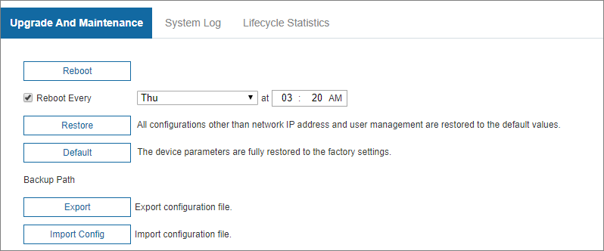
Table 5-2 Description of maintenance parameters
Parameter | Description
Reboot | Restart the device.  You can set the day and time that the system reboots.
Restore | All configurations except IP address and user management are restored to default settings.
Default | All parameters of the device are restored to factory settings.
Export | Export the configuration file (.backup file) to the local storage path.
Import Config | Import the configuration file, and then the device will complete the configurations.
Upgrade
Click Upgrade And Maintenance tab, and then configure the maintenance settings of the device.
Figure 5-4 Configure upgrade
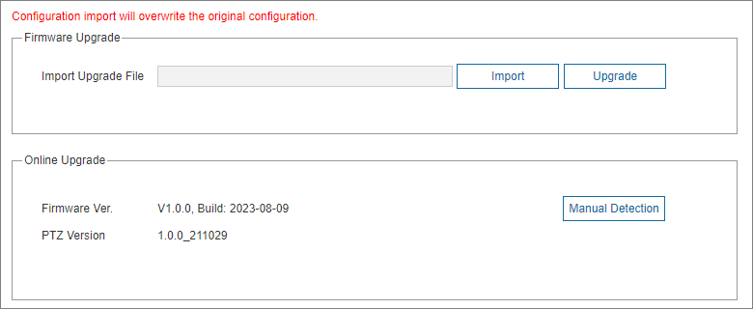
● Firmware Upgrade
1. Click Import, and then select the upgrade file. The upgrade file is in the format of *.bin.
2. Click Upgrade to upgrade the firmware.
● Online Upgrade
Click Manual Detection. If there is any upgrade available, click Upgrade, and then the system starts upgrading.
System Log
Click System Log tab, and then view the operation information of the device and system information.
Figure 5-5 Configure log
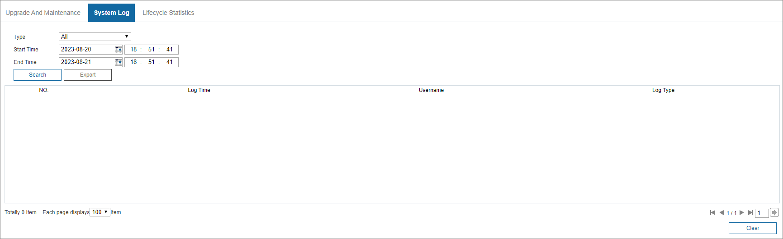
Table 5-3 Description of the log parameter
Parameter | Description
Type | The log type includes All, System Operations, Configuration Operations, Data Management, Event Operations, Recording Operations, User Management, Log Clearance, and Security.
Start Time | The start time of the log to be searched.
End Time | The end time of the log to be searched.
Search | Set the start time and end time of the log to be searched, select the log type, and then click Search. The searched log number and time period will be displayed.
Export | Export the searched system logs to the computer.
Here are the meanings of different log types.
● System Operations: Includes program launch, force exit, exit, program reboot, device shutdown/restart, system reboot, and system upgrade.
● Configuration Operations: Includes saving configurations, and deleting configuration files.
● Data Management: Includes disk type configurations, data erasing, hot swap, FTP state, and recording mode.
● Event Operation (records events such as video detection, smart plan, alarm, and abnormality): Includes starting events, and ending events.
● Recording Operations: Includes file access, file access error, and file search.
● User Management: Includes login, logout, adding user, deleting user, modifying user, adding group, deleting group, and modifying group.
● Log Clearance: Clearing logs.
● Security: Includes security-related information.
Lifecycle Statistics
Click Lifecycle Statistics tab, and then view Total Operating Time, Upgrade Count, and Last Upgrade Date of the device.
Figure 5-6 Lifecycle statistics
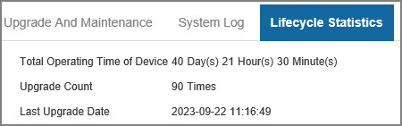

5.3 System Service
You can configure system service to ensure system security.
Procedure
Step 1 Select Settings > System > Security > System Service.
Step 2 Configure system service parameters.
Step 3 Click OK.
Figure 5-7 System service
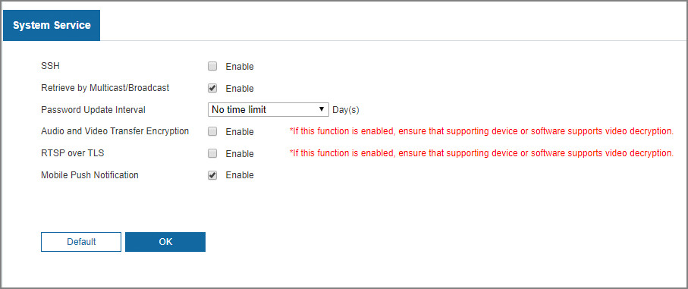
Table 5-4 Description of system service parameters
Parameter | Description
SSH | You can enable SSH authentication to perform safety management. The function is disabled by default.  It is recommended to disable SSH. If this function is enabled, there might be security risks.
Retrieve by Multicast/Broadcast | Enable this function, and when multiple users are viewing the monitoring screen simultaneously through network, they can find the Device through multicast/broadcast protocol.  It is recommended to disable the multicast/broadcast search function. If this function is enabled, there might be security risks.
Password Update Interval | Configure the password update interval. If the password remains unchanged after the validity period expires, the system will prompt you to change password.
Audio and Video Transfer Encryption | Enable this function to encrypt the stream transmitted through the private protocol.  ● Make sure that the matched devices or software support video decryption function.  ● It is recommended to enable the function. If the function is disabled, there might be risk of data leakage.
RTSP over TLS | Enable this function to encrypt the code transmitted through standard protocols.  ● Make sure that the matched devices or software support video decryption function.  ● It is recommended to enable the function. If the function is disabled, there might be risk of data leakage.
Mobile Push Notification | Push the alarm snapshot triggered by the Camera to the mobile phone. The function is enabled by default.  It is recommended to disable the function. If this function is enabled, there might be security risks.

5.4 User Management
User management is only available for admin users.
● For Username, the maximum length is 15 characters. Username can only consist of numbers, letters, underlines, dots and @; group name can only consist of numbers, letters and underlines.
● The password should consist of 8 to 32 non-blank characters and contain at least two types of characters among upper case, lower case, number, and special characters (excluding ' " ; : &). The confirming password shall be the same as the new password. Set a high security password according to the prompt of password strength.
● The number of users is 19 by default.
● Users currently logged in cannot modify their own permissions.
● The user is admin by default. The admin account is defined as high privileged user.
Select Settings > System > User Management > User Mana. to manage username and permission.
Add User
Add users in the group and set permissions.
As the default user with the highest authority, admin cannot be deleted.
1. Click Add User.
2. Enter Username and Password, confirm password, edit permission, and then manage Permission.
3. Click OK.
Figure 5-8 Add user
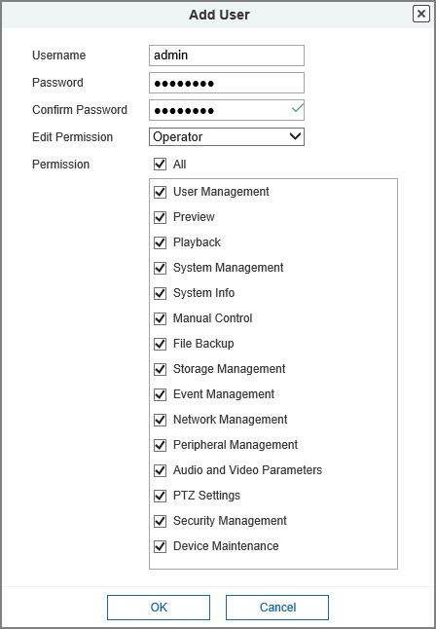
Modify User
1. Click next to the user you want to modify.
Click next to the user to delete the user.
2. Modify user information.
3. Click OK.
Figure 5-9 Modify user
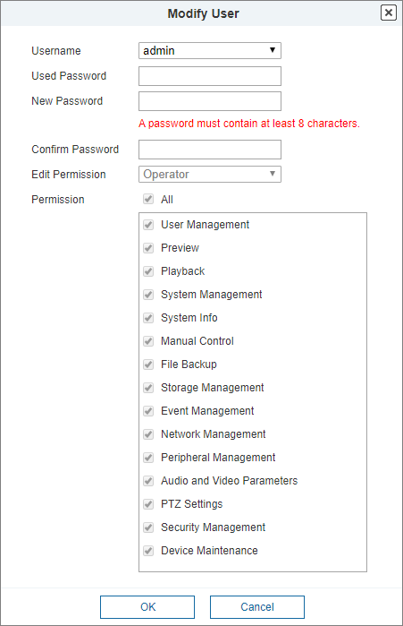
Add User Group
You have two groups named operator and user by default, and you can add new group, delete added group or modify group authority and memo.
1. Log in to the webpage of the device.
2. Select Settings > System > User Management > User Mana. > Edit Permission.
3. Click Add Group.
4. Enter the group name, and then select the permissions.
Figure 5-10 Add user group
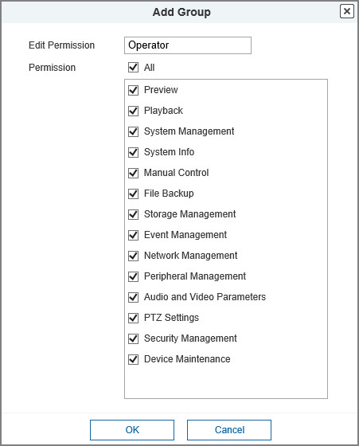
Table 5-5 Description of user group parameters
Permission | Function
Preview | Real-time stream view.
Playback | Playback view.
System Management | System time setting and more.
System Info | Version information, system logs and more.
Manual Control | PTZ settings.
File Backup | File backup.
Storage Management | Storage point configuration, snapshot recording time configuration, SFTP configuration and more.
Event Management | Video detection settings, audio detection settings, alarm settings and more.
Network Management | IP settings, SMTP settings, SNMP settings, AP Hotspot settings and more.
Peripheral Management | External light, wiper and serial port settings.
Audio and Video Parameters | Camera property settings, audio and video settings and more.
Security Management | HTTPS settings, RTSP over TLS settings and more.
Device Maintenance | Automatic maintenance settings and more.
Only user with specified permission can use corresponding function; the Operator group has all the permissions.
5. Click OK to finish the configuration.
The newly added group is displays on the group name list.
Modify User Group
1. Click to modify group permissions.
2. Click to delete the added group. Operator group and User group cannot be deleted.
Online User
Click Online User tab, and then view the information of the online user.
Figure 5-11 Online User
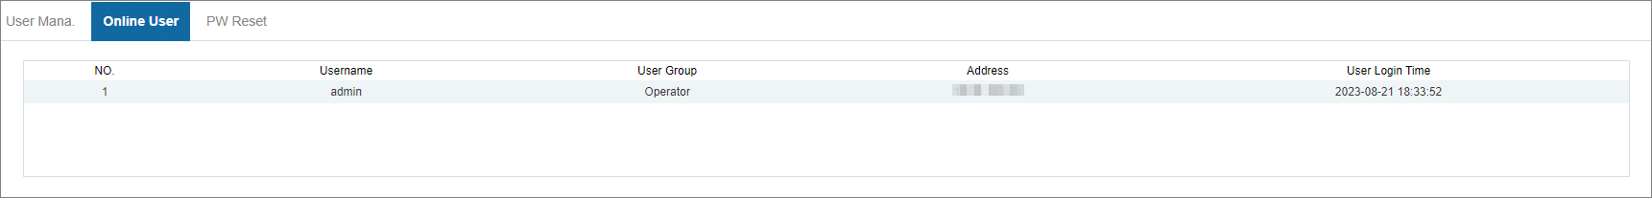
Password Reset
Click PW Reset tab, set your Reserved Email Address, and then click OK.
PW Reset is enabled by default. If this function is disabled, you can reset the password only by restoring defaults through hardware.
Figure 5-12 Online User
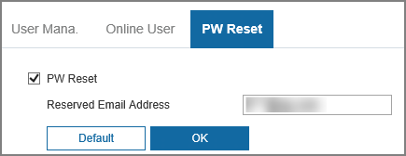

6 Network Settings

6.1 TCP/IP
You can configure the IP address and DNS server of the Camera to connect it to other devices in the network.
Prerequisites
Before configuring network parameters, make sure that the Camera is connected to the network properly.
● If there is no router in the network, assign an IP address in the same network segment.
● If there is a router in the network, set the corresponding gateway and subnet mask.
Procedure
Step 1 Select Settings > Network > TCP/IP.
Step 2 Click TCP/IP tab, and then set TCP/IP parameters.
Figure 6-1 TCP/IP
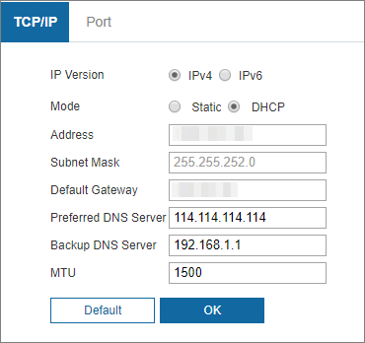
Table 6-1 Description of TCP/IP parameters
Parameter | Description
IP Version | You can select IPv4 or IPv6. Both versions are supported and can be accessed.
Mode | Static and DHCP are available.  ● If Static is selected, you need to set the IP address, subnet mask, and gateway manually.  ● If DHCP is selected, the IP address is obtained automatically. In this case, the IP address, subnet mask, and gateway cannot be set.
Address | Enter correct digits to change the IP address.
Subnet mask | Set the subnet mask according to actual conditions. The subnet prefix is a number in the range of 1 to 255. The subnet prefix identifies a specific network link, and usually contains a hierarchical structure.  The Camera checks the validity of all IPv6 addresses. The IP address and the default gateway must be in the same network segment. Make sure that a certain part of the subnet prefix in the IP address and default gateway are the same.
Default gateway | Configure as needed. The default gateway must be in the same network segment as the IP address. | For IPv6 version, in the IP Address, Default Gateway, Preferred DNS, and Alternate DNS fields, enter 128 bits, and these fields cannot be blank.
Preferred DNS server | IP address of the DNS server.
Backup DNS server | Alternate IP address of the DNS server.
MTU | You can set the MTU value to ensure good data transmission according to the network. The value is 1500 by default. Modifying MTU value causes Ethernet card restarting and network disconnection.  Here are some suggested values for your reference.  ● 1500: It is the maximum and default value of Ethernet packet, typical setting of the network connection without PPPoE or VPN, and is the default setting of some routers, network adapters, and switches.  ● 1492: The optimal value for PPPoE.  ● 1468: The optimal value for DHCP.  ● 1450: The optimal value for VPN.
Step 3 Click OK.
Related Operations
An Example of Configuring IP Address with ARP/Ping:
1. To obtain a usable IP address, make sure that the Device and your computer are in the same LAN.
2. Get the MAC address from the Camera label.
3. Open command editor on the computer and enter the following command.
Table 6-2 Command list
System | Command
Windows syntax | arp -s <IP Address> <MAC>  ping -l 480 -t < IP Address >  Example:  arp -s 192.168.1.125 11-40-8c-18-10-11  ping -l 480 -t 192.168.0.125
UNIX/Linux/Mac syntax | arp -s <IP Address> <MAC>  ping -s 480 < IP Address >  Example:  arp -s 192.168.1.125 11-40-8c-18-10-11  ping -s 480 192.168.0.125
Win7 syntax | netsh i i show in  netsh -c“i i” add neighbors ldx <IP Address> <MAC>  ping -l 480 -t < IP Address >  Example:  netsh i i show in  netsh -c“i i” add neighbors 12 192.168.1.125 11-40-8c-18-10-11  ping -l 480 -t 192.168.1.125
4. Power off the Camera and then restart it, or restart the Camera over the network.
5. Check the computer command line. If there is information such as "Reply from 192.168.1.125…", it means the configuration succeeds. In this case, you can close the command editor.
6. Enter http://<IP address> in the browser address bar to log in.

6.2 Port
Background Information
You can configure the maximum port numbers and values on this page.
Procedure
Step 1 Select Settings > Network > TCP/IP.
Step 2 Click Port, and then configure each port value of the Camera.
Step 3 Click OK.
Figure 6-2 Port
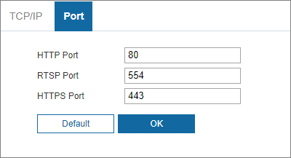
Table 6-3 Description of port parameters
Parameter | Description
HTTP Port | HTTP communication port. The value is 80 by default. You can set this parameter as needed.
RTSP Port | Real Time Streaming Protocol port. Keep the default value 554 if it is displayed. If you play live view through Apple’s QuickTime or VLC, the following format is available. This function is also supported by Blackberry mobile phone.  When the URL format requiring RTSP, you need to specify channel number and bit stream type in the URL, and also username and password if needed.  When playing live view with Blackberry mobile phone, you need to disable the audio, and then set resolution to CIF.  URL format example:  Rtsp://Username:Password@IP:Port/video/livemedia?Ch=1&Streamtype=0  ● Username: Your username. For example, admin.  ● Password: Your password. For example, admin.  ● IP: Your device IP. For example, 192.168.1.122.  ● Port: Leave it if the value is 554 by default.  ● Channel: Channel number starting from 1. For example, if it is channel 2, then enter Ch=2.  ● Subtype: stream type. The main stream is 0 (Streamtype=0); the sub stream is 1 (Streamtype=1).  For example, if you require the sub stream of channel 2 from a certain device, then the URL shall be:  rtsp://admin:admin123@10.81.93.175:554/video/livemedia?Ch=1&Streamtype=0  If certification is not required, you do not need to specify the username and password. Use the following format:  rtsp://ip:port/video/livemedia?Ch=1&Streamtype=0
HTTPS Port | HTTPS communication port. The value is 443 by default. You can set this parameter as needed.
● Modifications of all parameters will take effect after restart.
● 0–1024, 1900, 3800, 5000, 5050, 9999, 37776, 37780–37880, 39999, and 42323 are occupied for specific uses.
● It is not recommended to use the default values of other ports during port configuration.

6.3 P2P
Background Information
P2P is a private network traversal technology which enables users to manage devices easily without requiring DDNS, port mapping or transit server. Scan the QR code with your smart phone, and then you can add and manage more devices on your mobile client.
Procedure
Step 1 Select Settings > Network > P2P.
Step 2 Click the checkbox to enable the function.
Figure 6-3 P2P
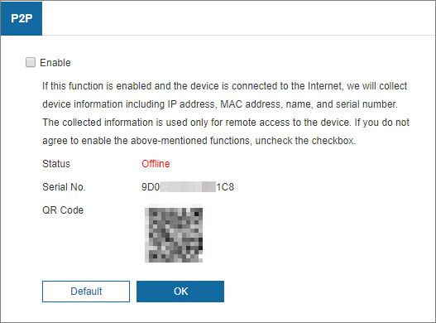
● You can manage the devices remotely.
● When P2P is enabled and the device is connected to network, the status is displayed as Online. We might collect the information including IP address, MAC address, device name, and serial number. The information collected is for remote access only. If you do not agree with this, you can clear the Enable checkbox.
Step 3 Log in to mobile phone client, and then tap Device Management.
Step 4 Tap Add at the upper-right corner.
Step 5 Scan the QR code on the P2P page.
Step 6 Follow the onscreen instructions to finish settings.

6.4 DDNS
Background Information
Properly configure DDNS, then the domain name on the DNS server matches your IP address and the matching relation refreshes in real time. You can always access your device with the same domain name no matter how much your device IP address changes. Before making any changes, check whether your device supports the DNS server.
● The third party servers might collect your device information if DDNS is enabled.
● Register and log in to the DDNS website, and then you can view the information of all the connected cameras in your account.
Procedure
Step 1 Select Settings > Network > DDNS.
Step 2 Select Type, and then configure DDNS parameters.
Figure 6-4 DDNS
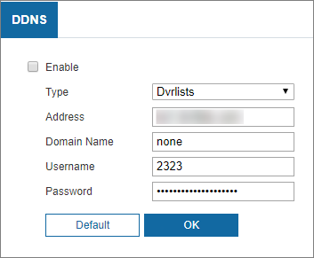
Table 6-4 Description of DDNS parameters
Parameter | Description
Type | The name and website of the DDNS service provider. Here is the matching relationship.  NO-IP DDNS  Server address: dynupdate.no-ip.com
Address
Domain Name | The domain name you registered on the DDNS website.
Username | Enter the username and password obtained from DDNS service provider. You need to register an account (including username and password) on the website of DDNS service provider.
Password
Step 3 Click OK.
Open the browser, enter the domain name in the address bar, and then press the Enter to display the login page.

6.5 Email
Background Information
After this function is enabled, the device data will be sent to the given server. There is data leakage risk. Think twice before enabling the function.
After you configure Email, when alarms, video detection and abnormal events are triggered, an email will be sent to the recipient server through SMTP server. The recipient can log in to the incoming mail server to receive emails.
Procedure
Step 1 Select Settings > Network > Email.
Step 2 Configure Email parameters.
Step 3 Click OK.
Figure 6-5 Email settings
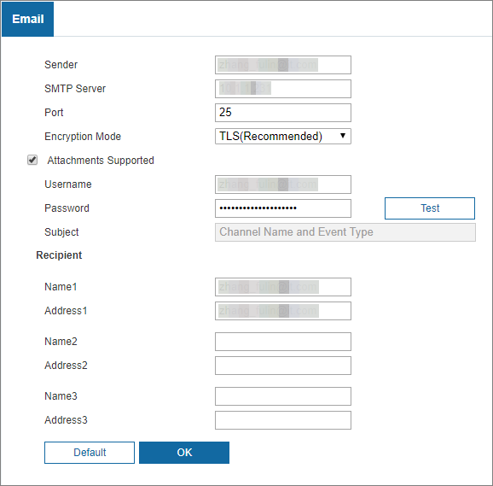
Table 6-5 Description of Email parameter
Parameter | Description
Sender | Email address of the sender.
SMTP Server | IP address of the outgoing mail server complying with SMTP protocol. | For the detailed configuration, see Table 6-6.
Port | Port number of the outgoing mail server complying with SMTP protocol. It is 25 by default.
Username | Username of sender mailbox.
Password | Password of sender mailbox.
Encryption Mode | Select encryption mode from None, TLS (Recommended) and SSL. TLS is selected by default.  ● For the detailed configuration, see Table 6-6.  ● There might be risks if you select the authentication type other than TLS. TLS is recommended.
Attachments supported | Select the checkbox to support attachment in the email.
Test | Test whether the email function is normal. If the configuration is correct, the email address of the receiver will receive the test email. Save the email configuration before running rest.
Subject | You can enter no more than 63 characters in Chinese, English, and Arabic numerals.
Recipient | Email address of the receiver. Support 3 addresses at most.
Attachments supported | Select the checkbox to support attachment in the email.
Table 6-6 Description of common email configuration
Type | SMTP Server | Authentication | Port | Description
Gmail | smtp.gmail.com | SSL | 465 | You need to enable SMTP service in your mailbox.
 |  | TLS | 587

6.6 Advanced

6.6.1 PPPoE
Background Information
You can enable PPPoE (Point-to-Point Protocol over Ethernet) to establish network connection. In this case, the Device obtains a dynamic IP address. To use this function, you need to obtain the PPPoE username and password from the Internet Service Provider (ISP).
Procedure
Step 1 Select Settings > Network > Advanced, and then click PPPoE Settings.
Step 2 Click the checkbox to enable the function, and then enter PPPoE username and password.
Step 3 Click OK.
Figure 6-6 PPPoE settings
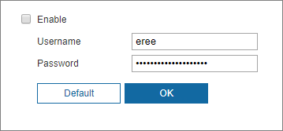
Saved! is displayed, and the obtained IP address of public network is displayed in real time. You can access the Camera through the IP address.

6.6.2 UPnP
After UPnP is enabled, Intranet service and port of the camera will be mapped to Extranet. Please be advised.
UPnP (Universal Plug and Play) allows you to establish the mapping relationship between Intranet and Extranet. Extranet users can access Intranet device by visiting Extranet IP address. Intranet port is device port and Extranet port is router port. Users can access the camera by accessing Extranet port. When you are not using routers for UPnP, disable UPnP to avoid affecting other functions.
Once UPnP is enabled, the device supports UPnP protocol. In Windows XP or Windows Vista, after UPnP is enabled, the Device can be automatically searched by Windows network.
Adding UPnP Network Service in Windows System
1. Open Control Panel, and then select Add or Remove Programs.
2. Click Add/Remove Windows Components.
3. Select Network Service from the Windows Components Wizard and click Details.
4. Select Internet Gateway Device Discovery and Control Client, and UPnP User Interface, and then click OK to start installation.
Configuring UPnP
1. Select Settings > Network > Advanced.
2. Select Enable.
3. Select a mode from the Mode drop-down list.
There are 2 mapping modes: Custom and Default.
● In Custom mode, you can modify the external port.
● In Default mode, the system finishes mapping with unoccupied port automatically. In this case, you do not need to modify mapping relation.
4. Select the checkbox to enable Enable the device discovery.
5. Click OK.
Figure 6-7 UPnP
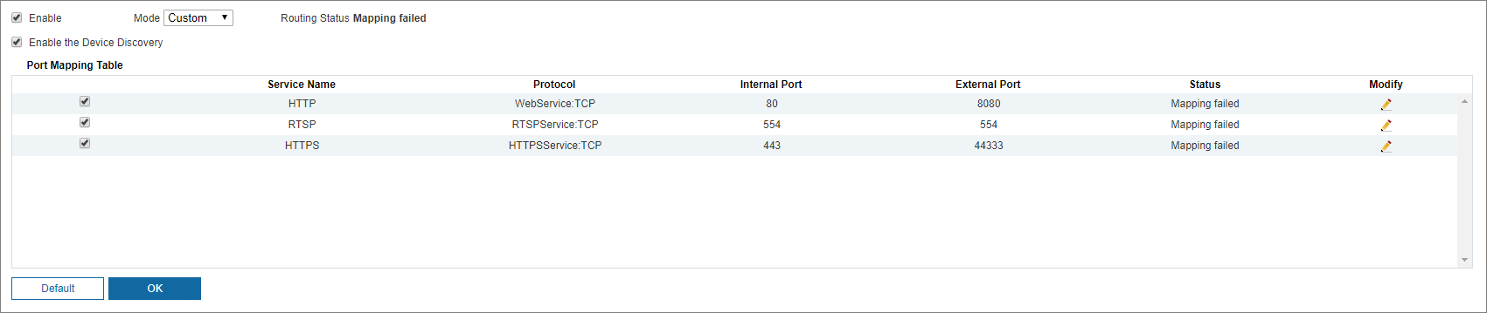

6.6.3 SNMP
After setting SNMP (Simple Network Management Protocol) and connecting to the Camera through certain software (such as MIB Builder and MG-SOFT MIB Browser), you can manage the Camera with the software.
Prerequisites
● Install SNMP monitoring and management tool such as MIB Builder and MG-SOFT MIB Browser.
● Get the MIB file of the matched version from technical support.
Procedure
Step 1 Select Settings > Network > Advanced, and then click SNMP tab.
Step 2 Select SNMP version to enable SNMP.
Step 3 Click OK.
● Select V1, and the system can only process information of V1 version.
● Select V2, and the system can only process information of V2 version.
● Select V3, and then V1 and V2 become unavailable. You can configure username, password and authentication type. It requires corresponding username, password and authentication type to access your device from the server.
Using V1 and V2 might cause data leakage, and V3 is recommended.
In Trap Address, enter the IP address of the computer that has MIB Builder and MG-SOFT MIB Browser installed, and leave other parameters as default.
Figure 6-8 SNMP(1)
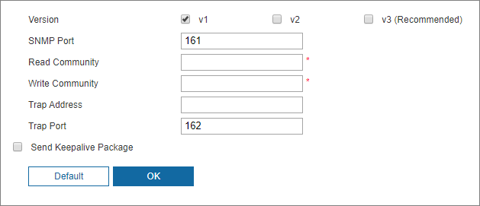
Figure 6-9 SNMP(2)
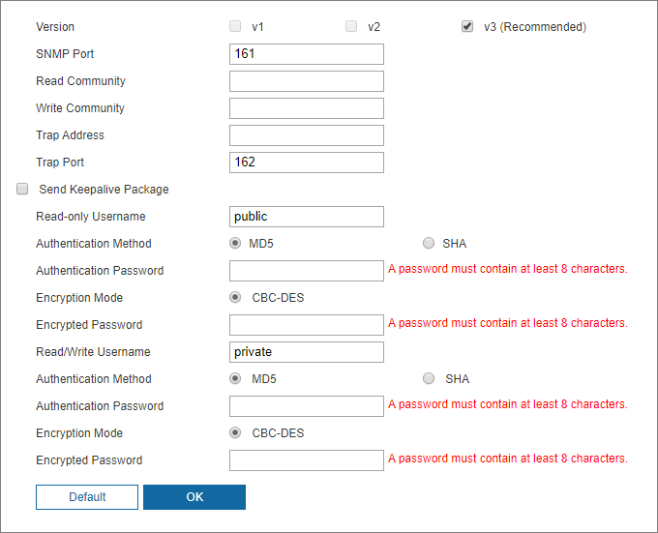
Table 6-7 Description of SNMP parameters
Parameter | Description
SNMP Port | The listening port of the software agent on the Camera.
Read Community | The read and write community string that the software agent supports.  The name must consist of numbers, letters, underlines and strikethroughs.
Write Community
Trap Address | The target address of the Trap information sent by the software agent on the Camera.
Trap Port | The target port of the Trap information sent by the software agent on the Camera.
Send Keepalive Package | After you select the checkbox, the Camera can send data packet to ensure continuous network connection.
Read-only Username | Set the read-only username used to access the Camera and it is public by default.  The name must consist of numbers, letters or underlines.
Read/Write Username | Set the read/write username used to access the Camera, and it is public by default.  The name must consist of numbers, letters or underlines.
Authentication Method | You can select MD5 or SHA. The default type is MD5.
Authentication Password | It cannot be less than 8 digits.
Encryption Mode | It is CBC-DES by default.
Encryption Password | It cannot be less than 8 digits.
Related Operations
View device configuration through MIB Builder or MG-SOFT MIB Browser.
1. Run MIB Builder and MG-SOFT MIB Browser.
2. Compile the two MIB files with MIB Builder.
3. Load the generated modules with MG-SOFT MIB Browser.
4. Enter the IP address of the Camera you need to manage in the MG-SOFT MIB Browser, and then select version to search.
5. Unfold all the tree lists displayed in the MG-SOFT MIB Browser, and then you can view the configuration information, video channel amount, audio channel amount, and software version.

6.6.4 Multicast
You can access the Camera by network to watch live view. If the access times exceed its upper limit, live view might fail. You can set multicast IP to access by multicast protocol to solve the problem.
Procedure
Step 1 Select Settings > Network > Advanced, and then click Multicast tab.
Step 2 Enable main stream or sub stream.
Step 3 Enter multicast address and port number.
Step 4 Click OK.
Figure 6-10 Multicast setting
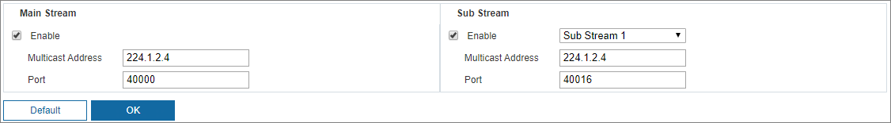

6.6.5 802.1x
Background Information
802.1x is a port-based network access control protocol. It allows users to manually select authentication mode to control device access to LAN, and meet authentication, billing, safety and management requirements of the network.
Procedure
Step 1 Select Settings > Network > Advanced, and then click 802.1x tab.
Step 2 Select the checkbox to enable 802.1x.
Step 3 Select an authentication mode, and then enter username and password.
Step 4 Click OK.
Figure 6-11 802.1x setting
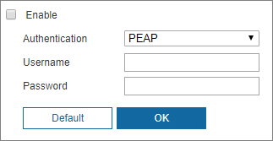
Table 6-8 Description of 802.1x setting parameter
Parameter | Description
Authentication | PEAP (protected EAP protocol).
Username | The username that was authenticated on the server.
Password | Corresponding password.

6.6.6 QoS
Background Information
QoS (Quality of Service) is a network security mechanism, and is also a technology to solve network delay, congestion, and other problems.
For network business, QoS includes transmission bandwidth, time delay in transmission, and packet loss of data. In network, QoS can be improved by ensuring transmission bandwidth, and reducing time delay in transmission, packet loss rate, and delay jitter.
For DSCP (Differentiated Services Code Point), there are 64 priority degrees (0 - 63) of data packets. 0 represents the lowest priority, and 63 the highest priority. Based on the priority, the packets are classified into different groups. Each group occupies different bandwidth and has different discard percentage when there is congestion so as to improve service quality.
Procedure
Step 1 Select Settings > Network > Advanced, and then click QoS.
Step 2 Configure QoS setting parameters.
Step 3 Click OK.
Figure 6-12 QoS setting
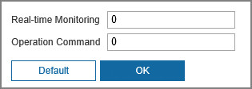
Table 6-9 Description of QoS setting parameter
Parameter | Description
Real-time Monitoring | Data packet of network video monitoring. The value ranges from 0 to 63.
Operation Command | Data packet of device configuration and query. The value ranges from 0 to 63.

6.6.7 RTMP
Background Information
You can connect the third party platforms (such as YouTube) to play live video through RTMP protocol.
● Only admin user can configure RTMP.
● RTMP only supports H.264 video format, and Advanced Audio Coding (AAC) audio format.
Procedure
Step 1 Select Settings > Network > Advanced, and then click RTMP tab.
Step 2 Select the checkbox next to Enable to enable RTMP.
When enabling RTMP, make sure that the address can be trusted.
Step 3 Set RTMP parameters.
Step 4 Click OK.
Figure 6-13 RTMP setting
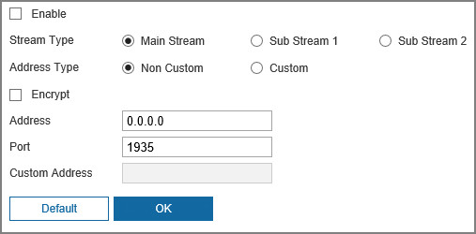
Table 6-10 Description of RTMP parameter configuration
Parameter | Description
Stream Type | Select live video stream type. Make sure that the video format of the stream is H.264, and the audio format is AAC.
Address Type | ● Non Custom: You need to enter the IP address or domain name.  ● Custom: You need to fill in the address allocated by the server.
Encryption | Select the checkbox next to Encrypt to enable encryption function.
Address | If you have selected Non Custom, IP address and port need to be filled in.  ● IP Address: IPv4 or domain name is supported.  ● Port: We recommend you use the default value.
Port
Custom Address | If you have selected Custom, the address allocated by the server needs to be filled in.

6.6.8 FTP
Background Information
FTP function can be enabled only when it is selected as a destination path.
Procedure
Step 1 Select Settings > Network > Advanced, and then click FTP tab.
Step 2 Select the checkbox to enable FTP function.
You can select FTP or SFTP.
● There might be risks if FTP is selected. Operate with caution.
● SFTP is recommended to ensure network security.
Step 3 Configure FTP parameters.
Step 4 Click Test to verify the username and password, and test whether FTP is connected to the Camera.
Step 5 Click OK.
Figure 6-14 FTP setting
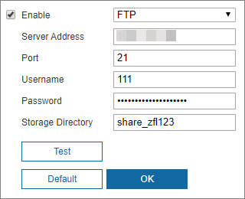
Table 6-11 FTP parameter description
Parameter | Description
Server Address | The IP address of the FTP server.
Port | The port number of the FTP server.
Username | The username to log in to the FTP server.
Password | The password to log in to the FTP server.
Storage Directory | The destination path on the FTP server.

6.6.9 NAS
Background Information
This function can be enabled only when NAS is selected as a destination path. Select NAS to store files on the NAS server.
Procedure
Step 1 Select Settings > Network > Advanced, and then click NAS.
Step 2 Configure NAS setting parameters.
Step 3 Click OK.
Figure 6-15 NAS settings
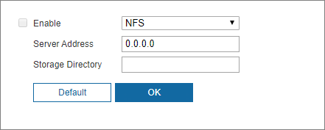
Table 6-12 Description NAS parameters
Parameter | Description
Enable | Select the checkbox to enable NAS function. Select NFS or SMB function.  There might be risks if NFS or SMB is enabled. Plea.
Server Address | The IP address of the NAS server.
Storage Directory | The destination path on the NAS server.

6.6.10 HTTPS
Background Information
It is recommended to enable HTTPS service. If the service is disabled, there might be risk of data leakage.
Create certificate or upload signed certificate, and then you can log in through HTTPS with your computer. HTTPS can ensure data security, and protect user information and device security with reliable and stable technology.
Procedure
Step 1 Create certificate or upload the signed certificate.
● If you select Create Certificate, refer to the following steps.
1) Select Settings > Network > Advanced, and then click HTTPS.
Figure 6-16 HTTPS (1)
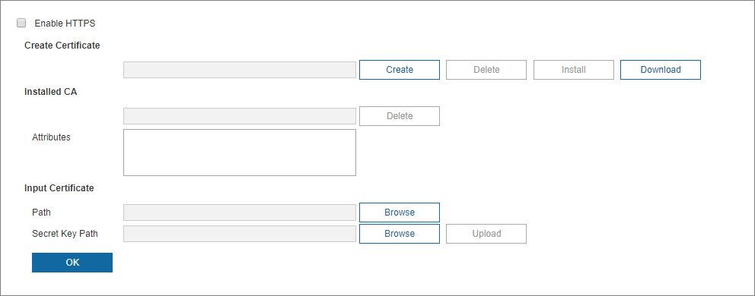
2) Click Create.
Figure 6-17 HTTPS (2)
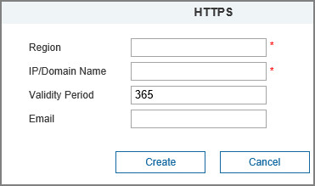
3) Enter the required information, and then click Create.
The entered IP or domain name must be the same as the IP or domain name of the Camera.
4) Click Install to install the certificate on the Camera.
Figure 6-18 Certificate installation
5) Click Download to download root certificate.
6) Double-click the RootCert.cer icon.
Figure 6-19 Certificate information
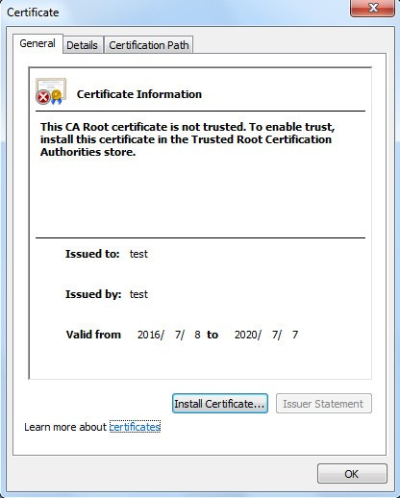
7) Click Install Certificate.
Figure 6-20 Certificate import wizard
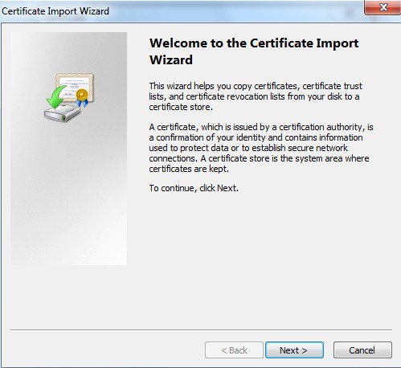
8) Click Next, and then select Trusted Root Certification Authorities.
Figure 6-21 Certificate storage area
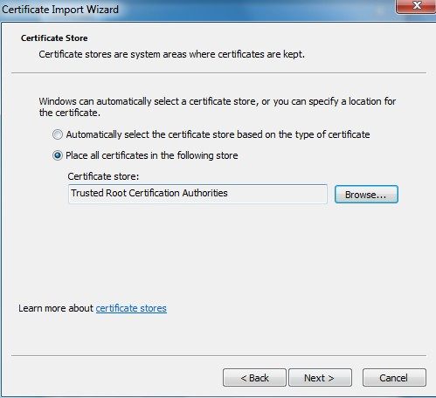
9) Click Next.
Figure 6-22 Completing the certificate import wizard
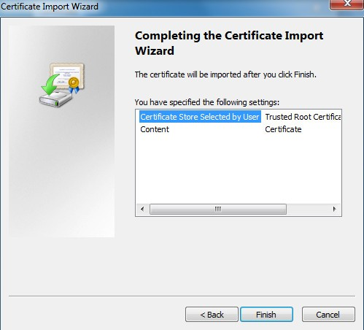
10) Click Finish.
11) Click Yes, and then click OK to complete the certificate installation.
Figure 6-23 Security warning
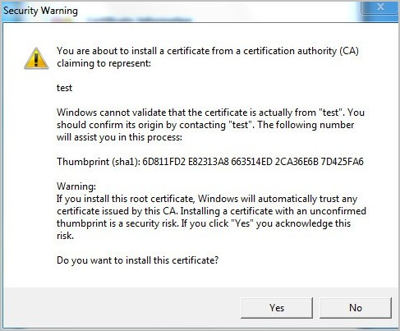
Figure 6-24 Import success
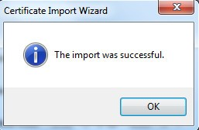
● If you select Input Certificate, refer to the following steps.
1) Select Settings > Network > Advanced, and then click HTTPS tab.
Figure 6-25 Install signed certificate
2) Click Browse to upload the signed certificate and certificate key, and then click Upload.
3) Install the root certificate. For details, see 5) to 11) in Step1.
Step 2 Select Enable HTTPS, and then click OK.
The configuration takes effect after reboot.
Enter https://xx.xx.xx.xx in the browser to open the login page. If no certificate is installed, a certificate error prompt will be displayed.
● If HTTPS is enabled, you cannot access the Camera through HTTP. The system will switch to HTTPS if you access the Camera through HTTP.
● The deletion of created and installed certificates cannot be restored. Think twice before deleting them.

6.6.11 Firewall
Configure Network Access, Disable PING or Half-open Connection Prevention to enhance network and data security. This section takes Network Access as an example.
Background Information
● Network Access: Set allowlist and blocklist to limit access.
◇ Allowlist: Only when the IP/MAC of your computer in the allowlist, can you access the camera. Ports are the same.
◇ Blocklist: When the IP/MAC of your computer is in the blocklist, you cannot access the camera. Ports are the same.
● Disable PING: Enable the Disable PING function, and the camera will not respond to the ping request.
● Half-open connection prevention: Enable Half-open connection prevention function, and the camera can provide service normally under Semijoin attack.
● You cannot set allowlist or blocklist for camera IP or MAC addresses.
● You cannot set allowlist or blocklist for port MAC addresses.
● MAC verification takes effect when the IP addresses of the camera and your computer are in the same LAN.
● When you access the camera through internet, the camera verifies the MAC address according to the router MAC.
Procedure
Step 1 Select Settings > Network > Advanced > Firewall.
Step 2 Select Enable to enable the firewall function.
Figure 6-26 Firewall
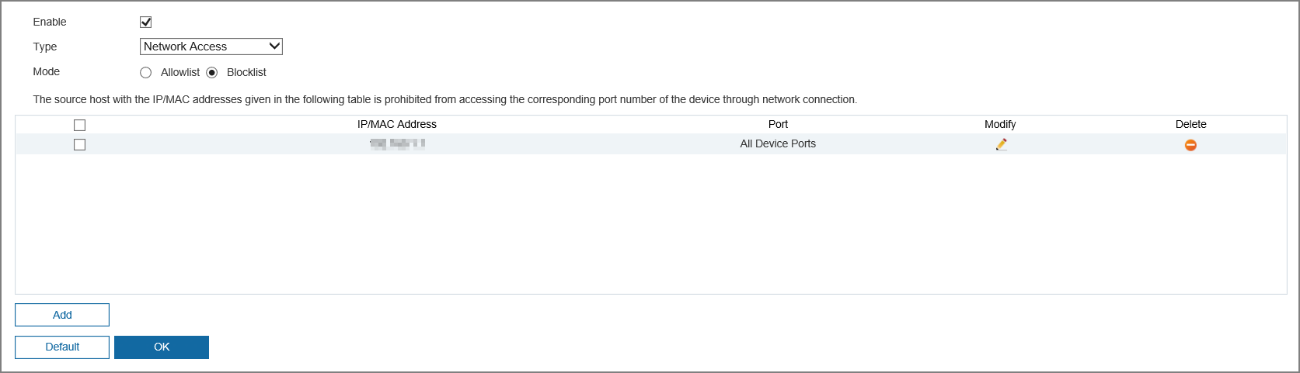
Step 3 Select Network Access from Type list, and then select the mode.
Step 4 Click Add to add the host IP/MAC address to Allowlist or Blocklist, and then click OK.
Figure 6-27 Firewall
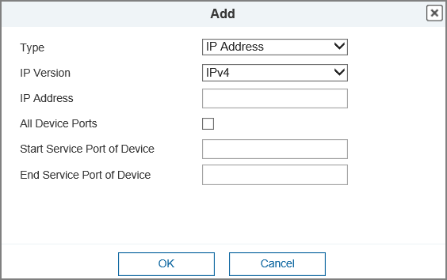
Step 5 Click OK.
Related Operations
● Click to edit the host information.
● Click to delete the host information.

6.6.12 ONVIF
Background Information
The ONVIF authentication is Enable by default, which allows the network video products (including video recording device and other recording devices) from other manufacturers to connect to the service.
Procedure
Step 1 Select Settings > Network > Advanced, and then click ONVIF.
Step 2 Select Enable for Login Verification.
Step 3 Click OK.
Figure 6-28 ONVIF page
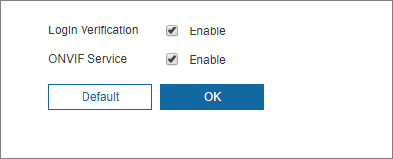

6.6.13 Remote Log Records
Upload the Device operations to the log server.
Procedure
Step 1 Select Settings > Network > Advanced > Remote Log Records.
Step 2 Select Enable to enable remote log function.
Step 3 Set the Address, Port and Device No. of the log server.
Figure 6-29 Remote Log Records
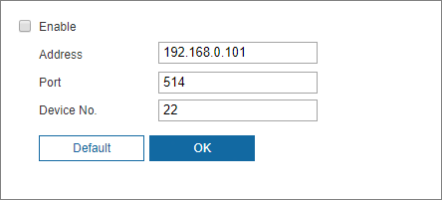

7 Video and Audio Settings

7.1 Video Settings
You can set the video stream and region of interest of the Camera.

7.1.1 Video Stream
Background Information
This section describes how to set the video stream for the monitoring screen.
Procedure
Step 1 Select Settings > Video/Audio > Video, and then click Video Stream.
Step 2 Configure video stream parameter.
● The stream configuration pages might vary depending on devices.
● The default bit rate of different devices might vary depending on different product.
Step 3 Click OK.
Figure 7-1 Video stream settings
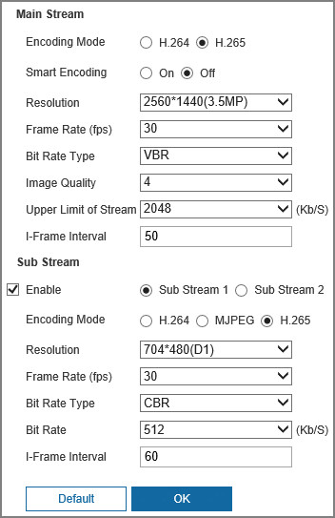
Table 7-1 Description of video stream parameters
Parameter | Description
Encoding Mode | Select encode mode.  Compared with H.264, H.265 requires smaller bandwidth.
Smart Encoding | Enable smart encoding to improve video compressibility and save storage space. It is applicable to static scenes.
Resolution | The resolution of the video. The higher the value, the clearer the image, but the bigger the bandwidth will be required.
Frame Rate (fps) | The number of frame in one second of video. The higher the value is, the clearer and smoother the video will be.
Bit Rate Type | The bit rate control type during video data transmission. You can select bit rate type from:  ● CBR (Constant Bit Rate): The bit rate changes a little and keeps close to the defined bit rate value.  ● VBR (Variable Bit Rate): The bit rate changes as monitoring scene changes.  The Bit Rate Type can be only be set as CBR when Smart Encoding is set as On.
Image Quality | Select image quality value according to actual condition.  The higher the image quality value is, the better the quality will be.  This parameter is available when the Bit Rate Type is VBR.
Bit Rate | Select bit rate value in the list according to actual condition.
I Frame Interval | The number of P frames between two I frames. The range varies with the frame rate, and the maximum value is 150. We recommend you set the interval twice the frame rate.

7.1.2 Region of Interest
Background Information
You can set a key monitoring region as a ROI (region of interest), and configure the image quality of this region.
ROI is available on select models.
Procedure
Step 1 Select Settings > Video/Audio > Video, and then click Region of Interest.
Step 2 Select Enable to enable this function.
Step 3 Press and hold the left mouse button to draw boxes on the monitoring screen. You can draw up to 8 boxes.
● Click Delete or right-click to delete the drawn boxes.
● Click Clear to clear all boxes.
Step 4 Set the image quality of the region of interest.
Step 5 Click OK.
Figure 7-2 Region of interest settings
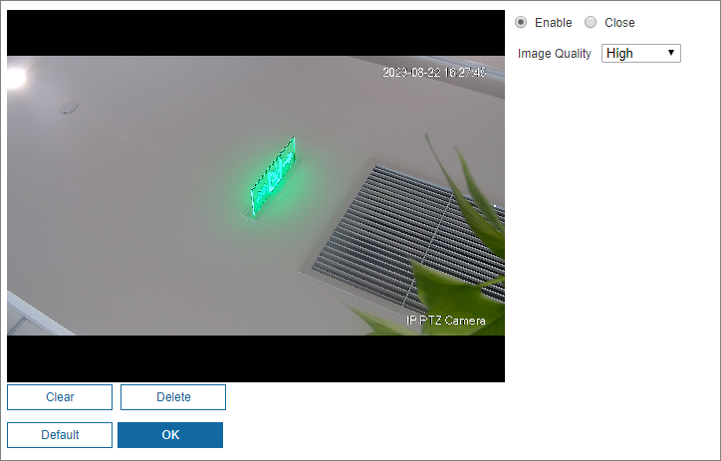

7.2 Audio Settings
You can configure audio parameters.
Prerequisites
Before enabling sub stream audio, go to Camera Settings > Video/Audio > Video, and then click Video Stream tab to enable video in sub stream.
Background Information
The function is available on select models.
You can set the audio input type, volume and more. After you enable main stream or sub stream, the network stream contains both audio and video; otherwise it is only video stream.
Procedure
Step 1 Select Settings > Video/Audio > Audio.
Step 2 Enable audio in main stream or sub stream.
Step 3 Configure audio parameters.
Step 4 Click OK.
Figure 7-3 Audio settings
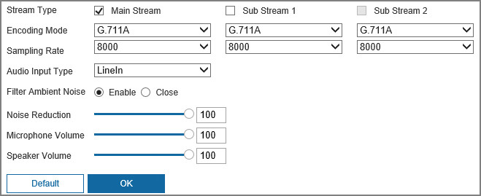
Table 7-2 Description of audio parameter
Parameter | Description
Stream Type | Enable audio in main stream or sub stream.  Audio can be enabled only when video has been enabled.
Encoding Mode | The audio encoding mode selected here applies to both audio streams and voice talks. We recommend you keep the default value.
Sampling Rate | The number of audio signals sampled per second. The higher the sampling frequency, the more samples obtained per unit time, and the more accurate the restored audio signals.
Audio Input Type | You can select audio input type from LineIn, Mic and realMic.  LineIn: The Camera collects audio signals through an external audio device.
Filter Ambient Noise | Enable this function, the system auto filters ambient noise.
Noise Reduction | Adjust noise reduction.
Microphone Volume | Adjust microphone volume.
Speaker Volume | Adjust speaker volume.

8 Image Settings

8.1 Display Settings
You can set Camera attributes and image parameters to get the best display effect.

8.1.1 Image Configuration
Procedure
Step 1 Select Settings > Image > Display Settings > Image.
Step 2 Configure image setting parameters.
Step 3 Click OK.
Figure 8-1 Image configuration
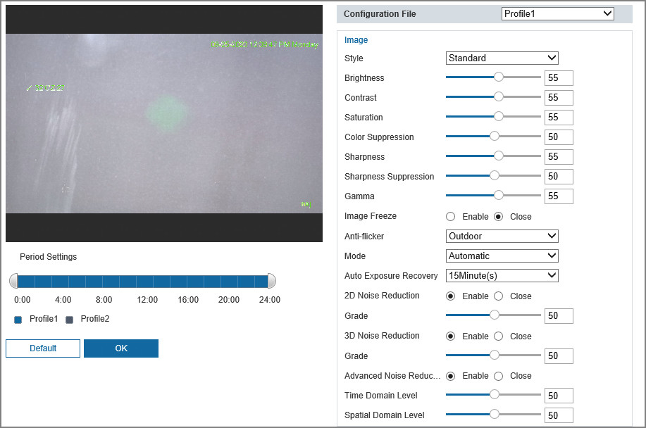
Table 8-1 Description of image setting parameters
Parameter | Description
Period Settings | You can select one period for Profile1, and another period for Profile2. For example, you can set the Profile1 from 6:00 to 18:00, and set the Profile2 from 18:00 to 6:00 on the next day.
Configuration File | There are two options: Profile1 and Profile2. You can view the configurations and the effect of the selected mode. Profile1 is selected by default.
Style | Set the image display style. There are three options: Soft, Standard, and Vivid. Standard is selected by default.
Brightness | Set the overall image brightness. The larger the value, the brighter the image. The value ranges from 0 to 100.
Contrast | Set the image contrast. The larger the value, the greater the contrast. The value ranges from 0 to 100.
Saturation | Set the intensity of colors. The larger the value, the brighter the colors. The value ranges from 0 to 100.
Color Suppression | The larger the value, the higher suppression on image colors. The value ranges from 0 to 100.  This parameter takes effect only when the Camera is under the environment with low luminance.
Sharpness | Set the sharpness of picture edges. The larger the value, the more obvious the edge will be. The value ranges from 0 to 100.  If the value is too large, there might be image noise. Set the value according to the actual condition.
Sharpness Suppression | The larger the value, the stronger the sharpness suppression. The value ranges from 0 to 100.  This parameter takes effect only when the Camera is under the environment with low luminance.
Gamma | Change image brightness through non-linear tuning to expand the dynamic display range of images. The larger the value, the brighter the image. The value ranges from 0 to 100.
Image Freeze | After enabling this function, the image at the called preset is displayed directly if you call a preset or tour, and no images during the rotation of the camera are displayed.
Anti-flicker | You can select 50Hz, 60Hz, or Outdoor from the list.  ● 50Hz: When the alternating current is 50 Hz, the exposure is automatically adjusted to make sure that there are no stripes on images.  ● 60Hz: When the alternating current is 60 Hz, the exposure is automatically adjusted to make sure that there are no stripes on images.  ● Outdoor: You can switch the modes to achieve the effect you want.
Mode | Set the exposure modes. You can select Automatic and Manual. The Automatic mode is selected by default.  ● Automatic: Exposure is automatically adjusted according to scene brightness if the overall brightness of images is in the normal exposure range.  ● Manual: You can adjust the Shutter value manually.
Shutter | You can adjust the exposure time of the Camera. The larger the shutter value, the brighter the image.
Auto Exposure Recovery | Automatic exposure is an automated digital camera system that adjusts the aperture and shutter speed, based on the external lighting conditions for images and videos. If you have selected an Auto Exposure Recovery time, the exposure mode will be restored to the previous mode after you adjust the iris value. There are five options: Close, 5Minute(s), 15Minute(s), 1Hour(s), and 2Hour(s).
2D Noise Reduction | 2D noise reduction is the process of removing noise from a signal. The higher the grade, the less the noise, and the blurrier the image.
3D Noise Reduction | 3D noise reduction is the process of removing noise from a signal. The higher the grade, the less the noise, and the blurrier the image.
Grade | Noise reduction grade. The value ranges from 0 to 100. The larger the value, the less the noise.
Advanced Noise Reduction | After enable the advanced noise reduction function, you can configure time domain level and spatial domain level.  ● Time Domain Level: The larger the value, the lower the noise, and the clearer and more realistic the image.  ● Spatial Domain Level: The larger the value, the lower the noise, and the more blurry the image.

8.1.2 Adjustment Configuration
Procedure
Step 1 Select Settings > Image > Display Settings > Adjustment.
Step 2 Configure adjustment setting parameters.
Step 3 Click OK.
Figure 8-2 Adjustment settings
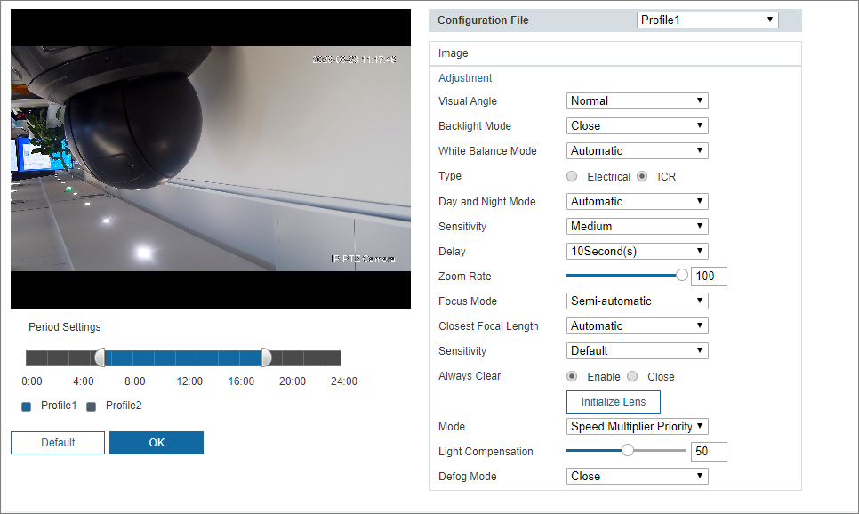
Table 8-2 Description of adjustment setting parameters
Parameter | Description
Visual Angle | Change the display direction of the image.  ● Normal: The monitoring video is normally displayed.  ● 180°: The monitoring video is upside down.
Backlight Mode | There are 4 options: Close, Backlight Compensation, Highlight Compensation, and Wide Dynamic Range.  ● Close: Backlight is disabled.  ● Backlight Compensation: Backlight compensation corrects regions with extremely high or low levels of light to maintain a normal and usable level of light for the object in focus.  ● Highlight Compensation: Highlight compensation dims strong light, so that the Camera can capture details of faces and license plates in extreme light conditions. It is applicable to the entrance and exit of toll stations or parking lots.  ● Wide Dynamic Range: When in WDR (Wide Dynamic Range) mode, the Camera constrains over bright areas and compensates dark areas to improve the image clarity.
White Balance Mode | You can select from Automatic, Indoor, Outdoor, Tracking, Manual, Sodium Lamp, Daylight, and Street Lamp. Automatic is selected by default.
Type | There are two options: Electrical and ICR. ICR is selected by default.  ● Electrical: Image processing method is used for day and night switch.  ● ICR: IR filter is used for day and night switch.
Day and Night Mode | Select a mode from the list (Your selection is independent from the profile). Automatic is selected by default.  ● Full Color: The Camera only outputs color images.  ● Automatic: The Camera outputs color images or black-and-white images according to ambient conditions.  ● Black & White: The Camera only outputs black-and-white images.
Sensitivity | Adjust the sensitivity to switch between different modes. There are three options: Low, Medium, and High.  You can set sensitivity only when Day and Night mode is set to Automatic.
Delay | Adjust the delay time to switch between different modes. The value ranges from 2 s to 10 s.  You can set Delay only when Day and Night mode is set to Automatic.
Zoom Rate | The larger the value is, the faster the Camera zooms.
Focus Mode | Select the focus triggering mode. There are three options: Semi-automatic, Automatic, and Manual. Semi-automatic is selected by default.  ● Semi-automatic: The Camera focuses automatically when zoom or ICR switch is detected.  ● Automatic: The Camera focuses automatically when scene changes, zoom, or ICR switch are detected.  ● Manual: The Camera cannot focus automatically. You need to adjust the focus manually.
Closest Focal Length | You can select the shortest focus distance, which means the Camera will focus on objects farther than the shortest focus distance. If you select Automatic, the Camera will select an appropriate shortest distance according to the zoom value.
Sensitivity | Sensitivity is the capacity of resisting interference of the Camera when focusing. The smaller the value is, the more capable the Camera can resist interference when focusing.
Always Clear | If you enable this function, the image is relatively clear during zoom. If you close this function, the speed is relatively high during zoom.
Initialize Lens | Click this button, and then the lens will be initialized automatically. The lens will be extended to calibrate the zoom and focus.
Light Setting Mode | Select the focus triggering mode. There are three options: Manual, SmartIR, Speed Multiplier Priority and Close. Speed Multiplier Priority is selected by default.  ● Manual: Adjust the brightness of illuminator manually, and then the system will supply illumination to the image accordingly.You can configure low beam and high beam to adjust the brightness.  This function is available on select models.  ● SmartIR: The system adjusts the illuminator intensity according to the ambient lighting condition.  Only infrared IR light supports the SmartIR mode.  ● Speed Multiplier Priority: The system adjusts the illuminator intensity automatically according to the change of the ambient light. You can configure light compensation manually to fine-tune the brightness of the illuminator.  ◇ When the ambient light turns darker, the system turns on the near light first, if the brightness is still not enough, then it turns on the far light.  ◇ When the ambient light turns brighter, the system dims far light until they are off, and then the near light.  ◇ When the focus reaches certain wide angle, the system will not turn on far light in order to avoid over-exposure in short distance.  In Speed Multiplier Priority mode, IR light and white light are supported, and IR light is selected by default.  ● Close: Illuminator is off.
Light Compensation | Select the light compensation for the illuminator. The value range is 0-100, and the default is 100.
Defog Mode | Select the defog mode of the Camera. You can select Automatic, Manual, or Close. It is Close by default.  For the Camera that supports optical defog, in Automatic mode, optical defog and electronic defog switch automatically according to the algorithm. And in Close mode, electronic defog is enabled by default.

8.2 OSD Settings
Procedure
Step 1 Select Settings > Image > OSD.
Step 2 Configure OSD setting parameters.
Step 3 Click OK.
Figure 8-3 OSD settings
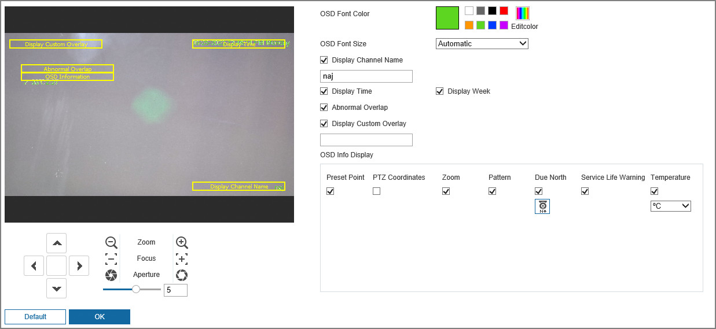
Table 8-3 Description of the OSD parameters
Parameter | Description
OSD Font Color | Select the font color.  Click Editcolor to customize the font color.
OSD Font Size | Select the font size.  There are three options: Large, Medium, Small and Automatic
Display Channel Name | Select the checkbox to display the channel name, and then enter the channel name.
Display Time | Select the checkbox to display the time and week.
Display Week
Abnormal Overlap | Select the checkbox to display exception information on the image.
Display Custom Overlay | Select the checkbox to display custom information on the video image.  You can enter the custom overlay information.
OSD Info Display | Select the information to be displayed on the video image.  ● Preset Point: Select the checkbox, and the preset name is displayed on the image when the camera turns to the preset, and it will disappear 3 s later.  ● PTZ Coordinates: Select the checkbox, and then the PTZ coordinates information is displayed on the image.  ● Zoom: Select the checkbox, and the zoom information is displayed on the image.  ● Pattern: Select the checkbox, and the pattern information is displayed on the image.  ● Due North: Select the checkbox, and the north direction is displayed on the image.  ● Service Life Warning: When the PTZ lifespan is close to the threshold, a warning will be displayed on the video image. This OSD info is enabled by default.  ● Temperature: Select the checkbox, and the internal temperature of the current device is displayed.

8.3 Privacy Mask
You can enable this function when you need to blur certain areas on the video image.
Procedure
Step 1 Select Settings > Image > Privacy Mask.
Step 2 Select the checkbox to enable the function.
Step 3 Click , select the Type and Color, set the Name, and then draw blocks on the image.
Click to delete the masking area.
Figure 8-4 Privacy mask
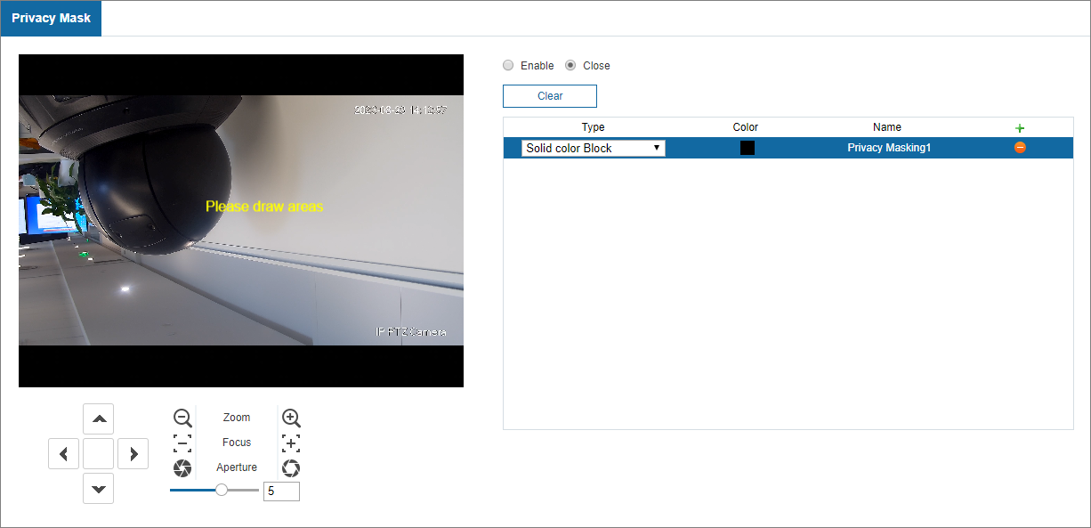

8.4 PTZ Settings

8.4.1 Configuring Basic Settings
Procedure
Step 1 Select Settings > Image, and then click Basic Settings tab.
Step 2 Configure basic PTZ settings.
Step 3 Click OK.
Figure 8-5 Basic PTZ settings
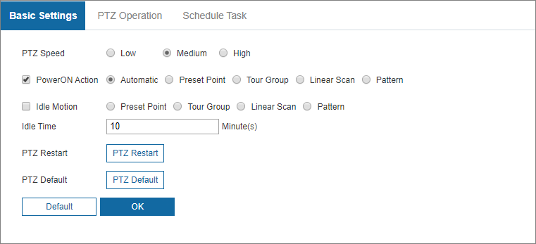
Table 8-4 Description of basic PTZ parameters
Parameter | Description
PTZ Speed | Adjust the manual control speed of the PTZ by setting PTZ speed. This speed does not apply to tour, pattern, or auto tracking.  There are three options: Low, Middle and High.
PowerON Action | Select the checkbox to enable Poweron Action motion.  There are five options: Automatic, Preset Point, Tour Group, Linear Scan and Pattern.
Idle Motion | Idle motion refers to a set motion when the Camera does not receive any valid command within a certain period.  Select the checkbox to enable Idle Motion.  There are four options: Preset Point, Tour Group, Linear Scan, and Pattern.
Idle Time | Set the time between the user manually operate the Camera and the Camera automatically rotates to the smart plan scene.
PTZ Restart | Click PTZ Restart to restart the PTZ.
PTZ Default | Click PTZ Default to restore the PTZ to factory defaults.

8.4.2 Configuring PTZ Operation

8.4.2.1 Preset Point
Preset means a certain position to which the Camera rotates. You can adjust the PTZ and Camera to the location quickly through calling presets.
Procedure
Step 1 Select Settings > Image > PTZ, and then click PTZ Operation.
Step 2 On the upper-right corner of the PTZ Operation page, click the direction buttons, , /, /, and / to adjust the PTZ direction, speed, zoom, focus and aperture of the Camera.
Step 3 Click to add a preset.
The current position is set to a preset and is displayed in the list.
Step 4 Click to save the preset.
Step 5 Perform operations on presets.
● Double-click the preset title to edit the title displayed on the monitoring screen.
● Click to delete the preset.
Figure 8-6 Preset point
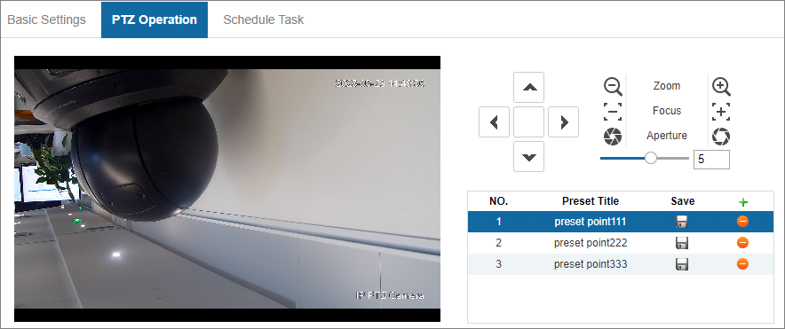

8.4.2.2 Tour Group
Tour means a series of movements that the Camera makes along several presets.
Prerequisites
You have set several preset points in advance. For details on preset, see "8.4.2.1 Preset Point".
Procedure
Step 1 Select Settings > Image > PTZ > PTZ Operation.
Step 2 Select Tour Group tab.
Step 3 Click Add to add a tour group, and then click Add to add several presets.
Step 4 Select the presets from the Preset Point drop-down list.
Repeat this step to add several presets for the tour group.
Step 5 Perform tour operations.
1) Double-click Tour Name to edit the name of the corresponding tour.
2) Double-click Stay time to set the time that the Camera stays at the corresponding preset.
3) Double-click Speed to modify the tour speed. The default value is 7, and the value range is 1 to 10. The larger the value, the faster the speed.
Step 6 Click Save to save the preset settings.
Step 7 Click Start to start the tour.
The ongoing tour stops if any operation is performed to the PTZ.
Figure 8-7 PTZ operation
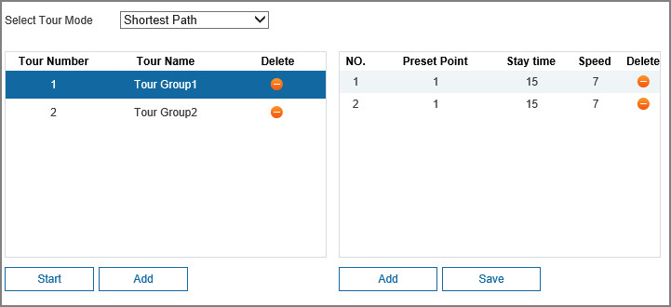

8.4.2.3 Linear Scan
Background Information
Scan means the Camera moves horizontally at a certain speed between the defined left and right limits.
Procedure
Step 1 Select Settings > Image > PTZ > PTZ Operation.
Step 2 Select Linear Scan.
Step 3 Select the Line Scan No..
Step 4 Drag the slider to adjust the scan speed.
Step 5 Click Settings to adjust the Camera to an ideal position.
Step 6 Click Set Left Margin and Set Right Margin to set the left and right boundaries of the Camera.
Step 7 Click Start, and then the Camera starts scanning.
Step 8 Click Stop, and then the scanning stops.
Figure 8-8 Linear scan
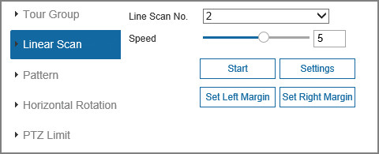

8.4.2.4 Pattern
Background Information
Pattern means a record of a series of operations that users make to the Camera. The operations include horizontal and vertical movements, zoom and preset calling. Record and save the operations, and then you can call the pattern path directly.
Procedure
Step 1 Select Settings > Image > PTZ > PTZ Operation.
Step 2 Select Pattern tab.
Step 3 Select the Pattern No..
Step 4 Select the Stay Time.
Stay Time: The time pattern information stays on the image between two patterns.
● Stay time is measured in seconds. The value ranges from 15 seconds to 3600 seconds.
Step 5 Click Settings and Start Recording, and then operate the PTZ to start recording.
Step 6 Click Stop Logging to stop logging.
Step 7 Click Start, and then the Camera starts patterning.
Step 8 Click Stop, and then the patterning stops.
Figure 8-9 Pattern settings
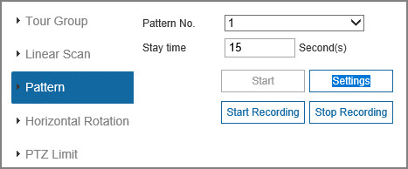

8.4.2.5 Horizontal Rotation
Background Information
Pan refers to the continuous 360° rotation of the Camera at a certain speed.
Procedure
Step 1 Select Settings > Image > PTZ > PTZ Operation.
Step 2 Select Horizontal Rotation tab.
Step 3 Drag the slider to set the Rotation Speed.
Step 4 Click Start, and the Camera starts to rotate horizontally at this speed.
Figure 8-10 Horizontal rotation
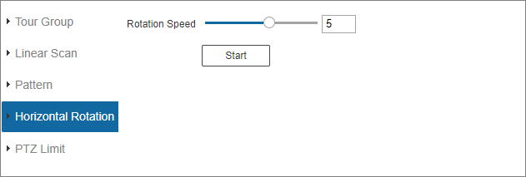

8.4.2.6 PTZ Limit
Background Information
After you set the PTZ limit, the Camera can only move in the defined area.
Procedure
Step 1 Select Settings > Image > PTZ > PTZ Operation.
Step 2 Select PTZ Limit tab.
Step 3 Select the checkbox to enable the PTZ limit function.
Step 4 Adjust the PTZ direction, and then click Settings to set the Upper Boundary.
Step 5 Adjust the PTZ direction, and then click Settings to set the Lower Boundary.
Step 6 Click Preview to preview the set up line and down boundary.
To view PTZ coordinates in real time, enable PTZ coordinates function on the Video Overlay screen.
Figure 8-11 PTZ limit
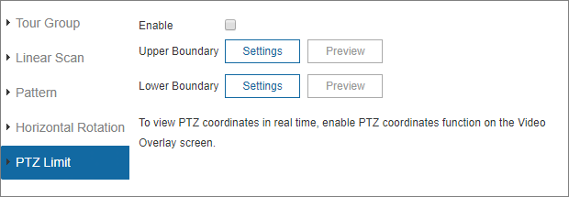

8.4.3 Configuring Schedule Task
After you set schedule task, the Camera performs the selected motions during the defined period.
Prerequisites
You have set Preset, Tour, Scan or Pattern in advance.
Procedure
Step 1 Select Settings > Image > PTZ > Schedule Task.
Step 2 Select the checkbox to enable Schedule Task function.
Step 3 Set the Timing Task No..
Click Clear All to delete all set time tasks.
Step 4 Select Task Action, including Preset point, Tour Group, Linear Scan and Pattern.
Step 5 Select the Action No. of the selected motion.
Step 6 Set the time for Auto Homing.
Auto Homing refers to the time needed to automatically recover the time task in case of manually calling the PTZ to stop the time task.
Step 7 Select the task time and week day to the selected task.
Step 8 Click OK.
Figure 8-12 Schedule task
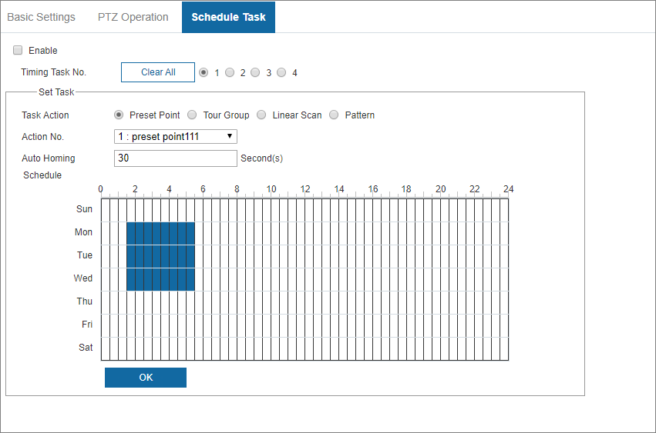

9 Event Management

9.1 Basic Event
You can configure basic events, including Motion Detection, Audio Detection, Video Tampering, and Alarm Linkage.

9.1.1 Motion Detection
When the moving object appears and moves fast enough to reach the preset sensitivity value, alarms will be triggered.
Procedure
Step 1 Select Settings > Event > Basic Event, and then select Motion Detection tab.
Step 2 Select the checkbox to enable motion detection, and then configure motion detection parameters.
1. Set the detection region.
You can set different motion detection regions for each area. The detection region can be irregular and discontinuous.
Figure 9-1 Detection region setting
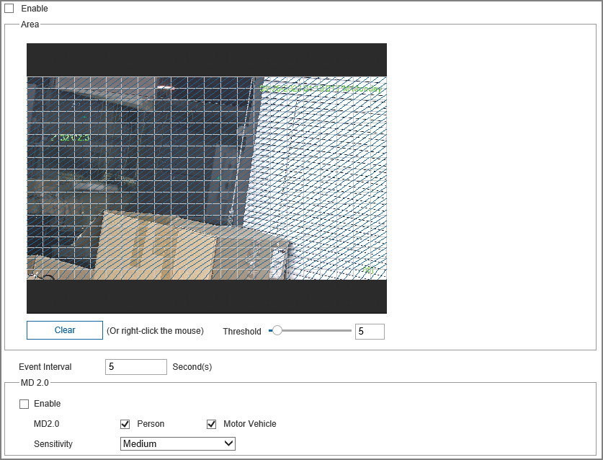
Table 9-1 Description of area setting parameters
Parameter | Description
Clear | Clear all detection regions.
Threshold | Detect the relation between the object and the region. The smaller the threshold, the easier the motion detection will occur.  Set different thresholds for each region, with values ranging from 0 to 100, and 1 to 10 is recommended.
Event Interval | One event can be triggered within the interval time. The time unit is second, and the value range is 0–100.
2. Configure MD 2.0.
You can select the MD2.0 target and the sensitivity. For details, see "9.1.2 MD2.0".
3. Set motion detection schedule and other parameters.
Figure 9-2 Motion detection schedule setting
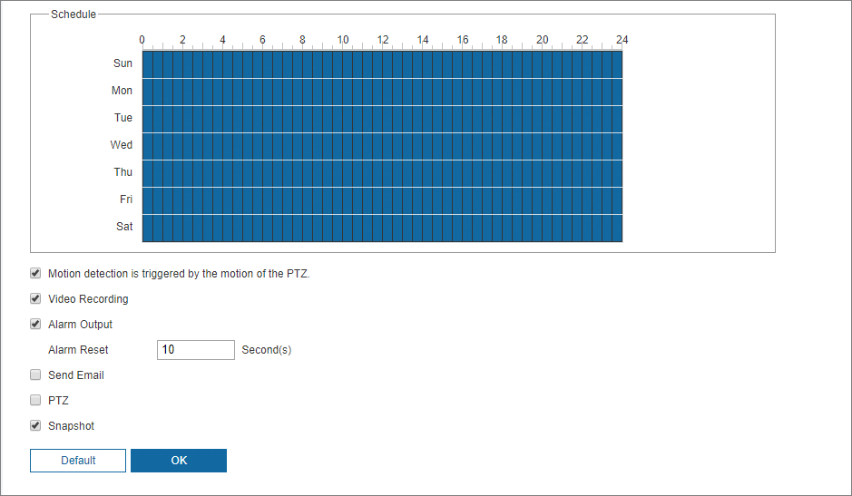
Table 9-2 Description of video detection parameter
Parameter | Description
Motion detection is triggered by the motion of the PTZ | After you enable the function, the motion detection events that occur when you control the PTZ manually will be excluded. In this way, you can reduce the false alarm rate of such events.
Video Recording | After you enable the function, when an alarm is triggered, the system will start recording automatically. Before using the function, you need to set the recording period of the alarm in Settings > Storage > Schedule, and select Events type on the Video Recording tab.
Alarm Output | Select the checkbox, and then you can enable the alarm linkage output port, and link corresponding relay-out devices after an alarm is triggered.
Alarm Reset | When the alarm is over, the alarm will continue for an extended period of time. The time unit is second, and the value range is 10–300.
Send Email | After you select the checkbox, when an alarm is triggered, the system sends email to the specified email address. You can configure the email address in .
PTZ | Select the PTZ checkbox, and then configure the linkage operation. When an alarm is triggered, the system links PTZ to rotate to the preset. The Linkage Operation include None, Preset Point, Tour Group and Pattern.
Snapshot | Select the Snapshot checkbox, and then the system takes snapshot automatically when an alarm is triggered. You need to set the alarm snapshot period as described in .
Step 3 Click OK.

9.1.2 MD2.0
Prerequisites
● You have enabled the motion detection function.
● You have set the arming period and detection area. The sensitivity of each region is larger than 0, and the threshold is not equal to 100.
Background Information
After you set smart motion detection, when the human, non-motor vehicles and motor vehicles appear and move fast enough to reach the preset sensitivity value, the alarm linkage actions will be performed. The function can help you to avoid the alarms triggered by natural environment change.
● The function depends on the result of motion detection, and all other parameters (except sensitivity) of motion detection function are used, including arming period, area settings, and linkage configurations. If no motion detection is triggered, smart motion detection will not be triggered.
● If motion detection is not enabled, when smart motion detection is enabled, motion detection will also be enabled. If both functions are enabled, when motion detection is disabled, smart motion detection will also be disabled.
● When smart motion detection is triggered and recording is linked, back-end devices can filter recording with human or vehicles through smart search function. For details, see the corresponding user’s manual.
Procedure
Step 1 Select Settings > Event > Basic Event, and then select Motion Detection.
Step 2 Select the checkbox to enable MD2.0.
Step 3 Select the alarm target and sensitivity.
● Alarm Target: Select Person or Motor Vehicle. When Person is selected, both people and non-motor vehicles will be detected.
● Sensitivity: Select High, Medium, or Low. The higher the sensitivity, the easier the alarm is triggered.
Step 4 Click OK.
Figure 9-3 MD2.0
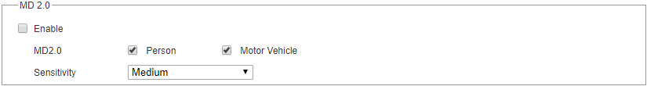

9.1.3 Audio Detection
Procedure
Step 1 Select Settings > Event > Basic Event, and then select Audio Detection tab.
Step 2 Configure audio detection parameter.
Step 3 Click OK.
For other parameters, see Table 9-2.
Figure 9-4 Audio detection
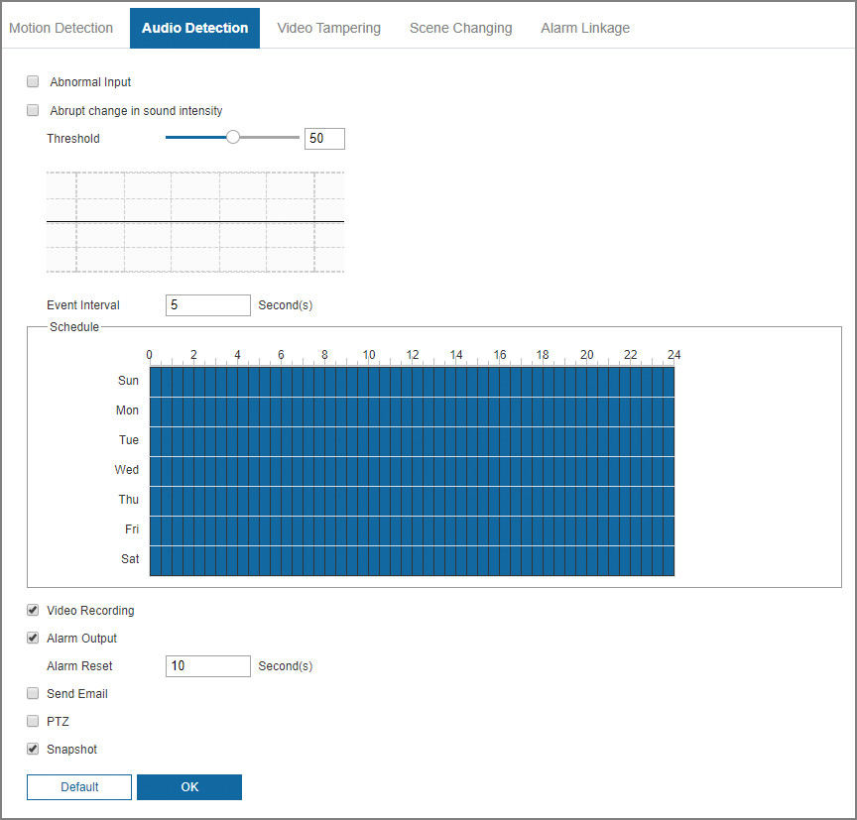
Table 9-3 Description of audio detection parameters
Parameter | Description
Abnormal input | Select the Abnormal input checkbox, and then an alarm is triggered when there is abnormal audio input.  The function is activated only when the audio function is enabled.
Abrupt change in sound intensity | Select the Abrupt change in sound intensity checkbox, and then an alarm is triggered when the change in sound intensity exceeds the defined threshold.
Threshold | The value ranges from 1 to 100. Configure the ambient sound intensity you need to filter. The louder the ambient noise, the larger the value. You need to adjust it according to the actual condition.
Event Interval | One event can be triggered within the interval time. The time unit is second, and the value range is 0–100.

9.1.4 Video Tampering
Alarms will be triggered if there is video tampering.
Procedure
Step 1 Select Settings > Event > Basic Event, and then select Video Tampering tab.
Step 2 Select the Enable checkbox, and then configure video tampering parameters.
For parameters configuration, see Table 9-2.
Figure 9-5 Video tampering
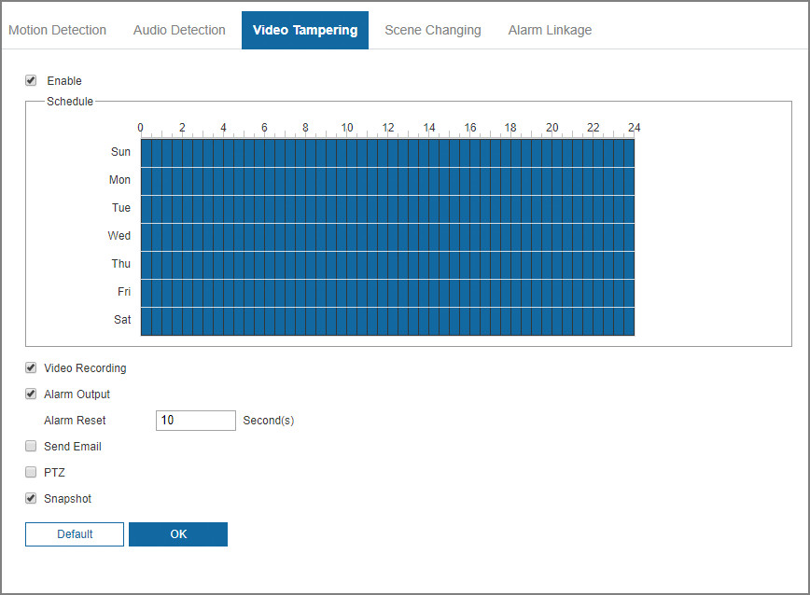
Step 3 Click OK.

9.1.5 Scene Changing
The system performs alarm linkage when the image switches from the current scene to another one.
Procedure
Step 1 Select Settings > Event > Basic Event, and then select Scene Changing tab.
Step 2 Select the Enable checkbox, and then configure video tampering parameters.
For parameters configuration, see Table 9-2.
Figure 9-6 Scene changing
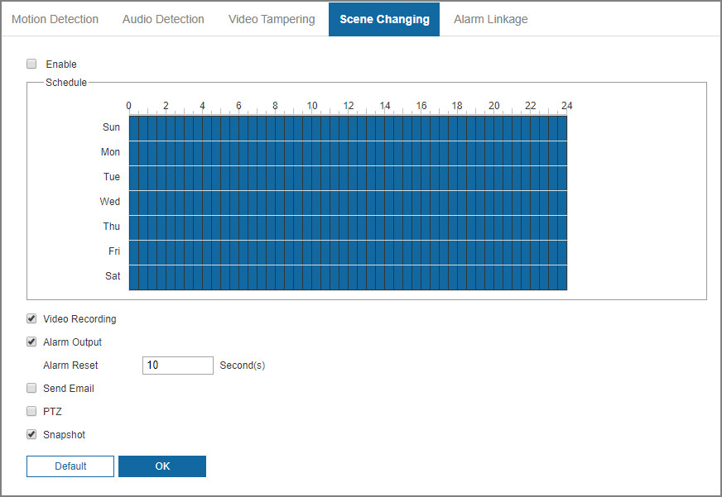
Step 3 Click OK.

9.1.6 Alarm Linkage
Procedure
Step 1 Select Settings > Event > Basic Event, and then select Alarm Setting tab.
Step 2 Configure alarm setting parameters.
For other parameters, see Table 9-2.
Figure 9-7 Alarm linkage
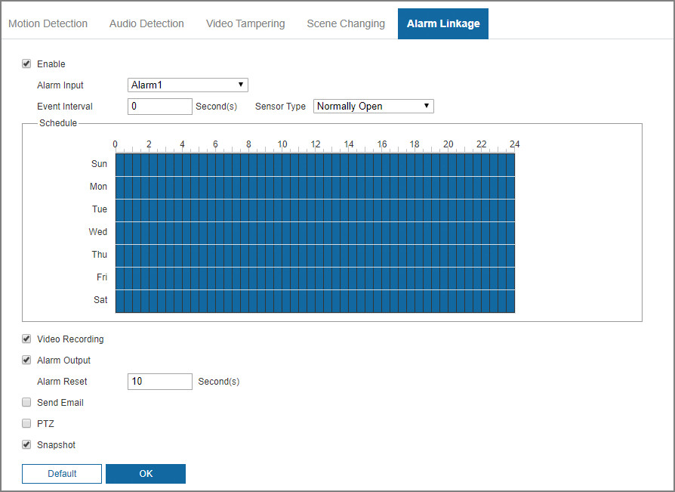
Table 9-4 Description of alarm setting parameter
Parameter | Description
Enable | Select the Enable checkbox, and then the alarm linkage is enabled.
Alarm input | Select alarm input, and 2 alarm inputs are available.
Event Interval | One event can be triggered within the interval time. The time unit is second, and the value range is 0–100.
Sensor Type | There are two types: Normally Open and Normally Closed.  ● Normally Open: The alarm input port and ground wire remain open under normal conditions, and an alarm is triggered only when the alarm input port and ground wire form a closed circuit  ● Normally Closed: The alarm input port and ground wire remain closed under normal confitions, and an alarm is triggered only when the alarm input port and ground wire are disconnected.
Step 3 Click OK.

9.2 VCA Option
Line Crossing and Intrusion and Face Detection can be enabled only after the VCA option is enabled. For details about how to configure the functions, see "9.3 VCA".
Procedure
Step 1 Log in to the webpage of the Camera.
Step 2 Click Settings > Event > VCA Option.
Figure 9-8 VCA option
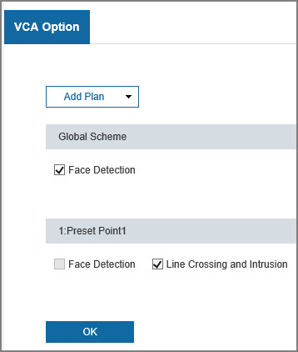
Step 3 Enable the smart functions of the global and preset plan based on actual needs, and then click OK.
Before configuring the preset plan, please add the appropriate presets in advance.

9.3 VCA
Procedure
Step 1 Log in to the webpage of the device.
Step 2 Click Settings > Event > VCA > Line Crossing and Intrusion.
Step 3 Click to add the rule.
Step 4 In the Type list, select Regional intrusion or Line Crossing and Intrusion as needed.
This section uses Line Crossing and Intrusion as an example.
● Missing Object: When the target crosses the tripwire from the defined motion direction, an alarm is triggered, and then the system performs configured alarm linkages.
● Line Crossing and Intrusion: When the target crosses tripwire from the defined motion direction, an alarm is triggered, and then the system performs configured alarm linkages.
● Abandoned object: When an object is abandoned in the detection area over the defined time, an alarm is triggered, and then the system performs defined alarm linkages.
● Parking detection: When the target stays over the defined time, an alarm is triggered, and then the system performs defined alarm linkages.
● Loitering detection: When the target loiters over the shortest alarm time, an alarm is triggered, and then the system performs defined alarm linkages. After alarm is triggered, if the target stays in the area within the time interval of alarm, then alarm will be triggered again.
● People Gathering: When people gather and stay in the detection area longer than the defined duration, an alarm is triggered, and then the system performs configured alarm linkages.
Figure 9-9 Configuring line crossing and intrusion
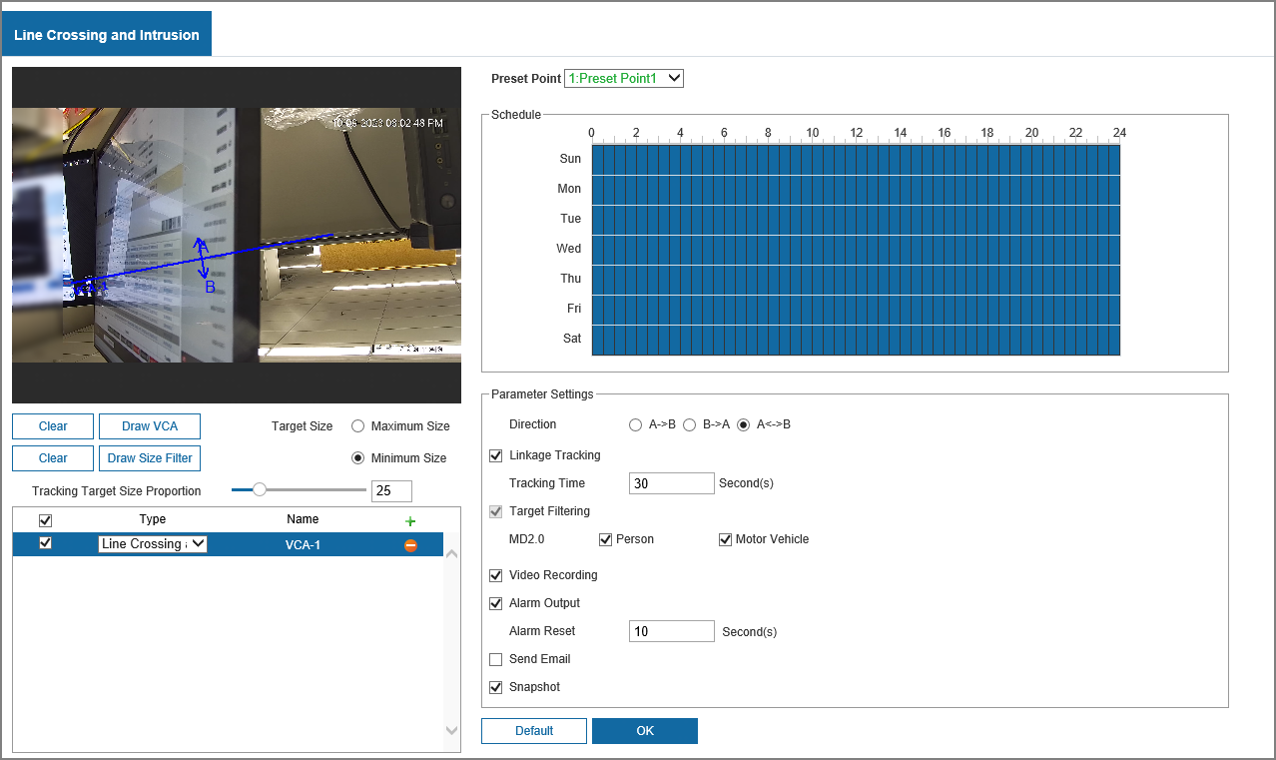
Step 5 Click Draw VCA to draw rule line in the image. Right-click to finish drawing.
Step 6 (Optional) Click other icons to filter targets in the image.
● Select Maximum Size to draw the maximum size of the target; Select Minimum Size to draw the minimum size. Only when the target size is between the maximum size and the minimum size, can the alarm be triggered.
● Click Clear next to Draw VCA to delete the line configured; Click Clear next to Draw Size Filter to delete the rectangle configured.
Step 7 Set rule parameters.
Table 9-5 Description of parameters
Parameter | Description
Direction | Set the direction of rule detection.  ● When setting tripwire, select A->B, B->A, or A<->B.  ● When setting intrusion, select Appear, Cross the region, or Within Area.
Sensitivity | When the sensitivity is high, detection becomes easier, but the number of false detections increases.  Regional intrusion does not support this function.
Linkage Tracking | Select Linkage Tracking to enable this function, and there will be alarm tracking when a smart rule is triggered.  You can set the tracking time as needed.  Tracking Time: Time of tracking after linkage tracking is triggered.
Target Filtering | Select Target Filtering to enable this function.  ● When you select Person as the alarm target, an alarm will be triggered when the system detects that person trigger the rule.  ● When you select Motor Vehicle as the alarm target, alarm will be triggered when the system detects that vehicle triggers the rule.
Step 8 Configure the alarm schedule and linkage. For details, see "9.1.6 Alarm Linkage".
Step 9 Click OK.

9.4 VCA Advanced
Background Information
When human face is detected in the monitoring screen, an alarm is triggered and the linked action is performed.
Procedure
Step 1 Select Settings > Event > VCA Advanced.
Figure 9-10 Face detection page
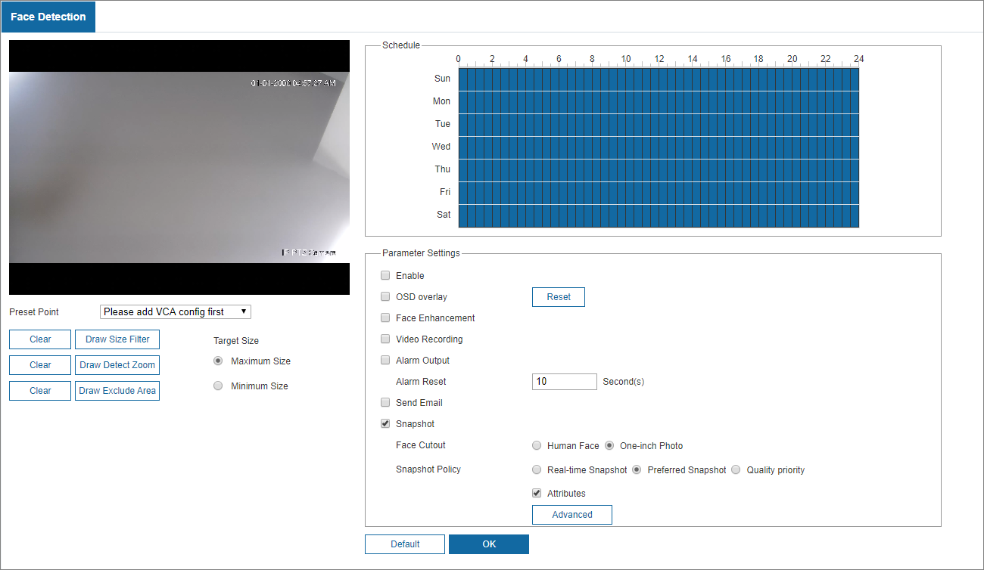
Step 2 Select the preset point from the drop-down list.
Step 3 (Optional) Draw the target size.
Select Maximum Size and click Draw Size Filter, and then select Minimum Size and click Draw Size Filter, you can draw the target size.
An alarm is triggered only when the face is between the maximum and minimum sizes.
Step 4 Click Draw Detect Zoom to draw the detection area, and then you can click Draw Exclude Area to the draw the exclusion area as needed.
The default is no exclusion area.
Step 5 Select Enable in Parameter Settings area to enable the face detection function.
Step 6 Set the alarming period to enable alarm events in the defined period.
Select the day of week. All days are selected by default; If all days are selected, the setting is applied to the whole week.
Step 7 Configure face detection parameters.
Table 9-6 Description of face detection parameter
Parameter | Description
OSD overlay | Select the checkbox to enable the OSD overlay. The statistics will be displayed on the Live view page in the form of OSD information.  The number of faces counted at each preset point is independent of each other, and will automatically reset to 0 after 12 o'clock at night.
Face Enhancement | Select Face Enhancement to preferably guarantee clear faces with low stream.
Video Recording | Select the checkbox, and when an alarm is triggered, the system will start recording automatically.
Alarm Output | Select the checkbox, and you can enable the alarm linkage output port, and link corresponding relay-out devices when an alarm is triggered.
Alarm Reset | When the alarm is over, the alarm will continue for an extended period of time until it resets. The value range is 10–300 s.
Send Email | Select the checkbox, and when an alarm is triggered, the system sends an email to the specified mailbox. You can configure the mailbox in Settings > Network > Email.
Snapshot | Select the checkbox, and the system will automatically take snapshots in case of alarms.
Face Cutout | Set the snapshot scope, including Human Face and One-inch photo.
Snapshot Policy | Select the snapshot policy, including Real-time Snapshot, Preferred Snapshot and Quality priority.
Advanced | Click Advanced Settings to set Quality Threshold and Preferred Duration during face detection.
Step 8 Click OK.

9.5 Exception
Exception includes abnormal SD card, network exception, unauthorized access, and security exception.
Select Settings > Event > Exception.
Abnormal SD Card
In case of SD card exception, the system performs alarm linkage. The event types include No SD Card, Insufficient SD Card Space, and SD Card Error. Functions might vary with different models.
1. Select the event type, and then click Enable checkbox to enable this function.
Figure 9-11 Abnormal SD Card
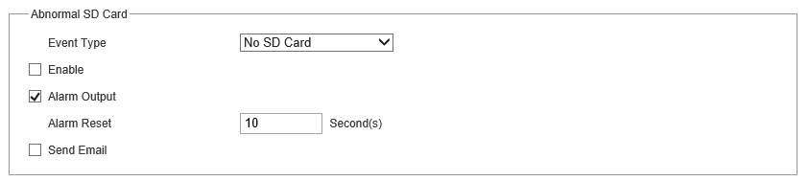
2. Set alarm linkage such as Alarm Output and Send Email. For details, see "9.1.6 Alarm Linkage".
Network Exception
In case of network abnormality, the system performs alarm linkage. The event types include Network Disconnected and IP Conflict.
1. Select the event type, and then click Enable checkbox to enable this function.
Figure 9-12 Network exception
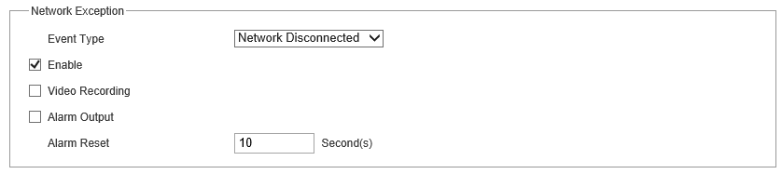
2. Set alarm linkage such as Alarm Output and Video Recording. For details, see "9.1.6 Alarm Linkage".
Unauthorized Access
When the number of login errors exceeds the configured times, the system performs alarm linkage such as alarm output and send email.
Voltage Detection
When the input voltage is higher than or lower than the rated value of the device, the system performs alarm linkage such as OSD, alarm output and send email.
Security Exception
When the system monitors the following events, an alarm can be triggered.
Figure 9-13 Security exception
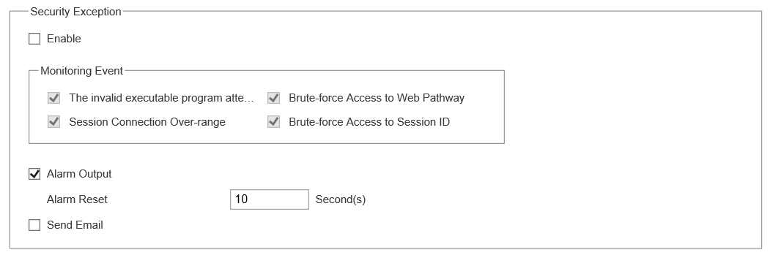

10 Storage Management

10.1 Configuring Schedule

10.1.1 Video Recording
Procedure
Step 1 Select Settings > Storage > Schedule > Video Recording.
Step 2 Set record plan.
Blue represents normal record plan (such as timing recording); yellow represents motion record plan (such as recording triggered by events). Select a record type, such as Normal, and directly press and drag the left mouse button to set the period for normal record on the timeline.
Figure 10-1 Video recording
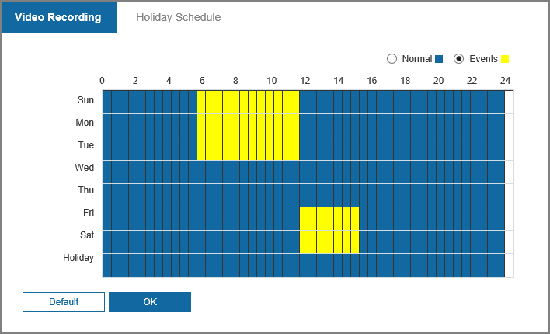
Step 3 Click OK.

10.1.2 Holiday Schedule
You can set certain days as holiday, and when the Video Recording or Snapshot is selected in the holiday schedule, the system takes snapshot or records video as holiday schedule defined.
Procedure
Step 1 Select Settings > Storage > Schedule > Holiday Schedule.
Step 2 Select Video Recording and Snapshot as needed, and then configure the time.
Figure 10-2 Holiday schedule
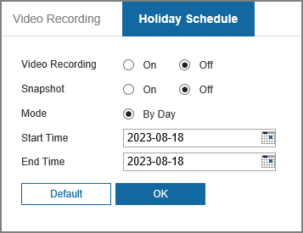
When holiday schedule setting is not the same as the general setting, holiday schedule setting is prior to the general setting. For example, with Holiday Schedule enabled, if the day is holiday, the system snapshots or records as holiday schedule setting; otherwise, the system snapshots or records as general setting.
Step 3 Click OK.

10.2 Configuring Storage

10.2.1 Storage Location
You can select different storage paths for the recorded videos and snapshots according to event type. You can select from SD card, FTP and NAS.
Procedure
Step 1 Select Settings > Storage > Storage > Storage Location.
Figure 10-3 Storage location
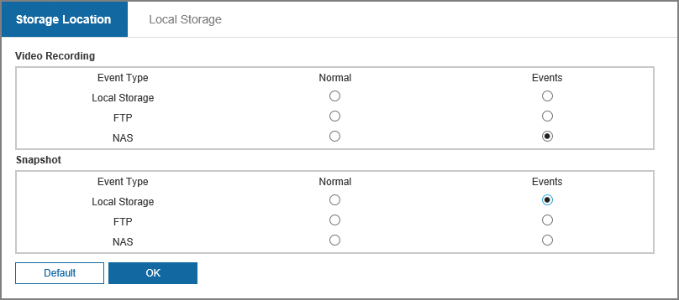
Step 2 Select the storage method that you need for the recorded videos and snapshots of different types.
Table 10-1 Description of storage location parameters
Parameter | Description
Local Storage | Save in the internal SD card.  Local Storage is displayed only on models that support SD card.
FTP | Save in the FTP server.
NAS | Save in the NAS (network attached storage).
Step 3 Click OK.

10.2.2 Local Storage
Display the information of the local SD card.
Procedure
Step 1 Select Settings > Storage > Storage > Local Storage.
Figure 10-4 Local storage
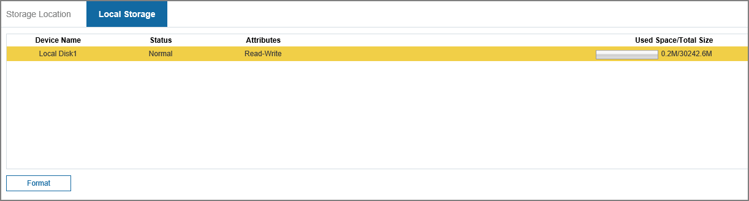
Step 2 (Optional) Click Format to clear the data of the SD card.

10.3 Configuring Recording Control
Procedure
Step 1 Select Settings > Storage > Recording Control.
Figure 10-5 Recording control
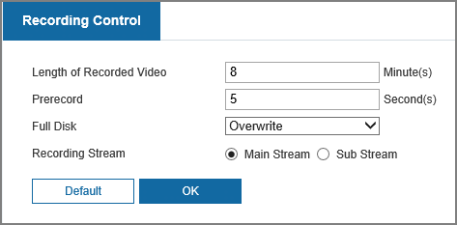
Table 10-2 Description of recording control parameters
Parameter | Description
Length of Recorded Video | The time for packing each video file.
Prerecorded | The time to record the video in advance of a triggered alarm event. For example, if the pre-event record is set to be 5 s, the system saves the recorded video of 5 s before the alarm is triggered.  When an alarm or motion detection links recording, and the recording is not enabled, the system saves the video data within the pre-event record time to the video file.
Full Disk | Recording strategy when the disk is full.  ● Stop: Stop recording when the disk is full.  ● Overwrite: Cyclically overwrite the earliest video when the disk is full.
Recording Stream | Select record stream, including Main Stream and Sub Stream.
Step 2 Click OK.

10.4 Snapshot

10.4.1 Configuring Snapshot Parameters
Procedure
Step 1 Select Settings > Storage > Snapshot > Parameter.
Figure 10-6 Configuring snapshot parameters
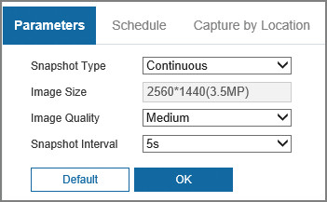
Table 10-3 Description of image stream parameters
Parameter | Description
Snapshot Type | You can select from Continuous and Event.
Image Size | The same resolution with main stream.
Image Quality | Configures the snapshot quality. There are six levels of Image quality, and the sixth is the best.
Snapshot Interval | Configures the snapshot frequency.  Select Custom, and then you can configure snapshot frequency manually.
Step 2 Click OK.

10.4.2 Configuring Snapshot Schedule
Procedure
Step 1 Select Settings > Storage > Snapshot > Schedule.
Step 2 Select snapshot type, and then set time period.
Figure 10-7 Configuring snapshot schedule
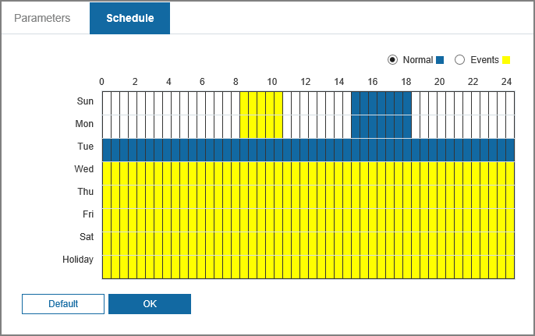
Select snapshot type, such as Events, and directly press and drag the left mouse button to set time period for normal snapshot on the timeline.
Step 3 Click OK.

10.4.3 Capture by Location
Procedure
Step 1 Select Settings > Storage > Snapshot > Capture by Location.
Step 2 Select Snapshot, and then select Enable All or Close All.
Figure 10-8 Capture by location
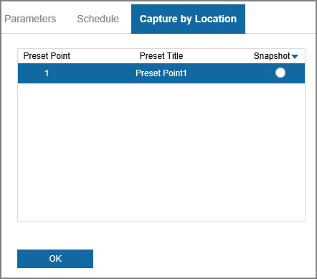
Step 3 Click OK.

Appendix 1 Cybersecurity Recommendations
Mandatory actions to be taken for basic equipment network security:
1. Use Strong Passwords
Please refer to the following suggestions to set passwords:
● The length should not be less than 8 characters.
● Include at least two types of characters; character types include upper and lower case letters, numbers and symbols.
● Do not contain the account name or the account name in reverse order.
● Do not use continuous characters, such as 123, abc, etc.
● Do not use overlapped characters, such as 111, aaa, etc.
2. Update Firmware and Client Software in Time
● According to the standard procedure in Tech-industry, we recommend to keep your equipment (such as NVR, DVR, IP camera, etc.) firmware up-to-date to ensure the system is equipped with the latest security patches and fixes. When the equipment is connected to the public network, it is recommended to enable the“auto-check for updates” function to obtain timely information of firmware updates released by the manufacturer.
● We suggest that you download and use the latest version of client software.
"Nice to have" recommendations to improve your equipment network security:
1. Physical Protection
We suggest that you perform physical protection to equipment, especially storage devices. For example, place the equipment in a special computer room and cabinet, and implement well-done access control permission and key management to prevent unauthorized personnel from carrying out physical contacts such as damaging hardware, unauthorized connection of removable equipment (such as USB flash disk, serial port), etc.
2. Change Passwords Regularly
We suggest that you change passwords regularly to reduce the risk of being guessed or cracked.
3. Set and Update Passwords Reset Information Timely
The device supports password reset function. Please set up related information for password reset in time, including the end user’s mailbox and password protection questions. If the information changes, please modify it in time. When setting password protection questions, it is suggested not to use those that can be easily guessed.
4. Enable Account Lock
The account lock feature is enabled by default, and we recommend you to keep it on to guarantee the account security. If an attacker attempts to log in with the wrong password several times, the corresponding account and the source IP address will be locked.
5. Change Default HTTP and Other Service Ports
We suggest you to change default HTTP and other service ports into any set of numbers between 1024–65535, reducing the risk of outsiders being able to guess which ports you are using.
6. Enable HTTPS
We suggest you to enable HTTPS, so that you visit Web service through a secure communication channel.
7. MAC Address Binding
We recommend you to bind the IP and MAC address of the gateway to the equipment, thus reducing the risk of ARP spoofing.
8. Assign Accounts and Privileges Reasonably
According to business and management requirements, reasonably add users and assign a minimum set of permissions to them.
9. Disable Unnecessary Services and Choose Secure Modes
If not needed, it is recommended to turn off some services such as SNMP, SMTP, UPnP, etc., to reduce risks.
If necessary, it is highly recommended that you use safe modes, including but not limited to the following services:
● SNMP: Choose SNMP v3, and set up strong encryption passwords and authentication passwords.
● SMTP: Choose TLS to access mailbox server.
● FTP: Choose SFTP, and set up strong passwords.
● AP hotspot: Choose WPA2-PSK encryption mode, and set up strong passwords.
10. Audio and Video Encrypted Transmission
If your audio and video data contents are very important or sensitive, we recommend that you use encrypted transmission function, to reduce the risk of audio and video data being stolen during transmission.
Reminder: encrypted transmission will cause some loss in transmission efficiency.
11. Secure Auditing
● Check online users: we suggest that you check online users regularly to see if the device is logged in without authorization.
● Check equipment log: By viewing the logs, you can know the IP addresses that were used to log in to your devices and their key operations.
12. Network Log
Due to the limited storage capacity of the equipment, the stored log is limited. If you need to save the log for a long time, it is recommended that you enable the network log function to ensure that the critical logs are synchronized to the network log server for tracing.
13. Construct a Safe Network Environment
In order to better ensure the safety of equipment and reduce potential cyber risks, we recommend:
● Disable the port mapping function of the router to avoid direct access to the intranet devices from external network.
● The network should be partitioned and isolated according to the actual network needs. If there are no communication requirements between two sub networks, it is suggested to use VLAN, network GAP and other technologies to partition the network, so as to achieve the network isolation effect.
● Establish the 802.1x access authentication system to reduce the risk of unauthorized access to private networks.
● Enable IP/MAC address filtering function to limit the range of hosts allowed to access the device.

